**1 .Project Profile**

**Project Title : RADHIKA FABRICS**

**Project Description : “RADHIKA FABRICS”** is a website which client ordering Fabrics products online.

**Project Duration :** 4 Months

**Platform :** Application will be embedded with Windows 10,11  
 Professional and deployed using Visual Studio

**Tool Used: 1. Editor Use:** Visual Studio 2010, 2022

**2. Browser :** Mozilla Firefox, Google Chrome

**Front End :** Asp.net

**Back end :** SQL Server 2014

**Team Size :** 3

**Team Member : Miss Shreya Viroja**,

**Miss Anjali Hingrajiya**,

**Miss Mital Gothi**

**Submitted To :** M. M. Ghodasara Mahila Arts & Commerce College, Junagadh

**Project Guide :**  Dr. Raksha K. Bathani

**2 .Introduction & Objectives**

**Introduction**

The online RADHIKA FABRICS web site has been undertaken by me since last Fifth months. So, what is online product purchasing?

In this site, a customer can order RADHIKA FABRICS online. If a customer is new user then he first fill his form for the id & if the customer is regular then no need. If a customer wants any product from the list then they click on the product. His request is stores on the database and appropriate reply is possible.

“The **RADHIKA FABRICS** web based application. It consists of a database, as scalable back-end, and sites that support a variety of methods for submitting purchase order requests.

The project provides the following facilities:

1. Login and registration for new user.
2. You can order Fabrics products.
3. Create new products.
4. Create a New User Account etc.
5. View different reports e.g. product report.
6. Browse products without login.

**Objectives**

1. To develop a complete user interactive application.
2. Reduce manually work for solution.
3. Provide better result and maximum satisfaction to customers.

**3. Tools & Technology**

* This project is developed using the tools, which are most suited for development of the Application Package. These tools are as follows: -
* **Front End:** Visual Studio 2010,2022 (ASP.Net 4.0)
* **Back End:** SQL Server 2014(R2)
* **Introduction of .Net**

.NET is an object-oriented programming (OOP) model introduced to help developers create internet-based distributed systems. It provides a platform-independent framework that enables developers to quickly build, deploy and manage web-based application, smart client applications and xml web services applications. The platform-independence features enable business to quickly integrate their systems, information and devices, thereby helping users collaborate and communicate effectively.

* **Features**
* It is a new environment for developing and running software applications.
* It provides the framework for an internet-centric industry standard that makes it possible.
* Implement a service-oriented architecture by trying together applications, information and data, Source using web services.
* It enables software to become platform and device-independent.
* It employs many standard run-time services available to components written in variety of programming languages. It has inter-language and inter-machine operability.
* **What is .NET Framework?**
* The .NET Framework is a common environment for building, deploying, and running Web Services and Web Applications. The .NET Framework contains common class libraries - like ADO.NET, ASP.NET and Windows Forms - to provide advanced standard services that can be integrated into a variety of computer systems.
* The .NET Framework is language neutral. Currently it supports C++, C#, Visual Basic, JScript (The Microsoft version of JavaScript) and COBOL. Third-party languages - like Eiffel, Perl, Python, Smalltalk, and others - will also be available for building future .NET Framework applications.
* The new Visual Studio.NET is a common development environment for the new .NET Framework. It provides a feature-rich application execution environment, simplified development and easy integration between a number of different development languages.
* **The .NET Framework Architecture**

#### ASP.NET is based on the fundamental architecture of .NET Framework. Visual studio provides a uniform way to combine the various features of this Architecture.

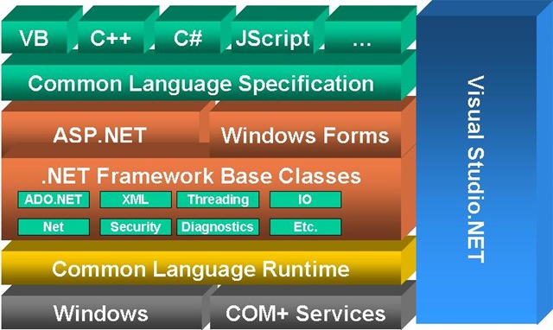

* Architecture is explained form bottom to top in the following discussion.
* At the bottom of the Architecture is Common Language Runtime. NET Framework common language runtime resides on top of the operating system services. The common language runtime loads and executes code that targets the runtime. This code is therefore called managed code. The runtime gives you, for example, the ability for cross-language integration.
* .NET Framework provides a rich set of class libraries. These include base classes, like networking and input/output classes, a data class library for data access, and classes for use by programming tools, such as debugging services. All of them are brought together by the Services Framework, which sits on top of the common language runtime.
* ADO.NET is Microsoft’s ActiveX Data Object (ADO) model for the .NET Framework. ADO.NET is not simply the migration of the popular ADO model to the managed environment but a completely new paradigm for data access and manipulation.
* ADO.NET is intended specifically for developing web applications. This is evident from its two major design principles:
* Disconnected Datasets, In ADO.NET, almost all data manipulation is done outside the context of an open database connection.
* Effortless Data Exchange with XML, Datasets can converse in the universal data format of the Web, namely XML.
* The 4th layer of the framework consists of the Windows application model and, in parallel, the web application model. The Web application model-in the slide presented as ASP.NET comes with built-in Web Forms controls, which are responsible for generating the user interface. They mirror typical HTML widgets like text boxes or buttons. If these controls do not fit your needs, you are free to create your own user controls.
* Web Services brings you a model to bind different applications over the Internet. This model is based on existing infrastructure and applications and is therefore standard-based, simple.
* Web Services are software solutions delivered via Internet to any device. Today, that means Web browsers on computers, for the most part, but the device-agnostic design of .NET will eliminate this limitation.
* One of the obvious themes of .NET is unification and interoperability between various programming languages. In order to achieve this; certain rules must be laid and all the languages must follow these rules. In other words we cannot have languages running around creating their own extensions and their own fancy new data types. CLS is the collection of the rules and constraints that every language (that seeks to achieve .NET compatibility) must follow.
* The CLR and the .NET Frameworks in general, however, are designed in such a way that code written in one language can not only seamlessly be used by another language. Hence ASP.NET can be programmed in any of the .NET compatible language whether it is VB.NET, C#, Managed C++ or JScript.NET

#### KEY BENEFITS OF .NET

* **Ease of Use**
* Object-oriented model
* Everything is an object
* Namespace and Framework structure
* Easier to comprehend and use
* Naming scheme of namespace reflects the underlying functionality
* **Freedom to choose**
* The language that meet your needs.
* The development tool that is best for you
* The “feature and functionality” to “plug in to”
* **Security**
* Restricting or containing the illegal memory reference
* Comprehensive security model
* Assembly specific
* System wide
* Code inspection through MSIL
* **Deployment and Management**
* Deployment: Code is “Assembled” and Run “Securely”
* Maintenance: Version Maintenance Simplified
* **Web Services**
* The web the Way You Want It
* Anywhere
* Anytime
* On any device
* **ASP.NET**
* .NET provides a complete environment for building, deploying and running .NET Web application.
* **Feature Of Asp.Net**
* ASP.NET has better language support, a large set of new controls , XML based Components and better user authentication.
* ASP.NET provides increased performance by running compiled code.
* ASP.NET code is not fully backward compatible with ASP.
* **New In Asp.Net**
* Better language support
* Programming controls
* Event-driven programming
* XML based components
* User authentication, with accounts and roles
* Higher scalability
* Increased performance –Compiled code
* Easier configuration and deployment
* Not fully ASP compatible
* **Language Support**
* ASP.NET uses the new ADO.NET.
* ASP.NET supports full, not VBScript.
* ASP.NET supports C#(C sharp) and C++.
* ASP.NET supports jScript as before
* **ASP.NET Controls**
* ASP.NET contains a large set of HTML controls; almost all HTML elements on a page can be defined as ASP.NET controls objects that can be controlled by scripts.
* ASP.NET also contains a new set of object oriented input controls, like programmable list and validation controls.
* A new data grid control supports sorting, data paging, and everything you expect from dataset controls.
* **Asp.Net Components**
* ASP.NET components are heavily based on XML, Like the new AD Rotator ,

That uses XML to store advertisement information and configuration.

* **User Authentication**
* ASP.NET components forms based user authentication, including cookies

management and automatic redirecting of unauthorized logins.

* You can still do your custom login page and custom user checking.
* **Compiled Code**
* The first for an ASP.NET page on the server will compile the ASP.NET code and keep a cached copy in memory. The results of this are greatly increased performance.
* **Easy Deployment**
* No more server restart to deploy compiled code. ASP.NET simply redirects allNew request to the new code.
* **Back End Tool(SQL Server 2014(R2)**
* SQL Server 2008 R2 boasts a number of new services, including PowerPivot for Excel and SharePoint, Master Data Services, Stream Insight, Report Builder 3.0, Reporting Services Add-in forSharePoint, a Data-tier function in Visual Studio that enables packaging of tiered databases as part of an application, and a SQL Server Utility that manages multiple SQL Servers.
* Power Pivot allows end users to import, manipulate, analyze and export data, as well as create reports, all using the familiar Excel interface and language.  
  -- Master Data Services is a new and powerful feature designed to help an organization create a structure and hierarchy for data, so that data collected and used across multiple departments, silos and databases is standardized and aligned. This ensures that different databases are interoperable.
* Stream Insight is a new platform integrated with .Net and SQL Server for processing streams of data in parallel, allowing for many simultaneous queries running on live data.
* The data-tier functionality in Visual Studio is designed to make it simple to create n-tier applications that use databases on the back end, and package the entire application including the database as a single unit.  
  -- The SQL Server Utility allows for a single management dashboard across multiple servers and databases.
* **Key features include:**
* A new Control Point Explorer for central multi-instance and application utilization management.
* Built-in wizards to help you quickly set up and enroll instances and Data-Tier Application components into central management.
* Dashboard viewpoints for quick insight into application and instance utilization.
* Report Builder 3.0
* Power Pivot for Microsoft Excel
* Master Data Services
* Stream Insight core technology engine.
* **Microsoft Sql Server as Database**
* A database is a collection of data arranged in such a way that we can easily

Extract information from it.

* We have User SQL Server as backend.
* There are many reasons for the SQL Server to be chosen as backend.
* Maximum database size roughly 1,000,000 Terabytes.
* To put that in perspective we could store 100 megabytes in a single SQL Server

Database.

* Up to 16 simultaneous instances of SQL Server can run on single computer.
* This helps in running complex Internet Site.
* It has support for up to 32 processors in single instance.
* Support for up to 64 Gigabytes of physical RAM.
* Built in support for Extensible Markup Language XML.
* Indexed Views.
* Cascading referential integrity.
* Data mining support in analysis services. Basically with the depth and range of it, it is Enterprise-level database server.

**Other Tools**

#### Adobe Photoshop:

* When creating graphics on a computer, there is a distinction between painting and drawing. Painting involves changing the colors of pixels using a painting tool. You can apply colors gradually, with soft edges and transitions, and manipulate individual pixels using powerful filter effects. However, once you apply a brush stroke, there is no simple way to select an entire brush strike and move it to a new location in the image.

#### Mozilla Firefox:

* Mozilla Firefox 7.0 and more makes it easier to get the most from the World Wide Web, whether you are searching for new information or browsing your favorite web sites. Built-in intelligence technology can save you time completing routine web tasks, such as automatically completing web addresses and forms for you, and automatically detecting your and connection status.

#### ADO.NET Overview

* ADO.NET is an evolution of the ADO data access model that directly addresses user requirements for developing scalable applications. It was designed specifically for the web with scalability, statelessness, and XML in mind.
* ADO.NET uses some ADO objects, such as the **Connection** and **Command** objects, and also introduces new objects. Key new ADO.NET objects include the **Dataset**, **Data Reader**, and **Data Adapter**.
* The important distinction between this evolved stage of ADO.NET and previous data architectures is that there exists an object -- the **DataSet** -- that is separate and distinct from any data stores. Because of that, the **DataSet** functions as a standalone entity.
* You can think of the DataSet as an always disconnected record set that knows **Connections:** For connection to and managing transactions against a database.

**Commands**: For issuing SQL commands against a database.

**Data Readers**: For reading a forward-only stream of data records from a SQL Server data source.

**Datasets**: For storing, Removing and programming against flat data, XML data and relational data.

**Data Adapters**: For pushing data into a **Dataset**, and reconciling data against a database.

* When dealing with connections to a database, there are two different options: SQL Server .NET Data Provider (System.Data.SqlClient) and OLE DB .NET Data Provider (System.Data.OleDb). In these samples we will use the SQL Server .NET Data Provider. These are written to talk directly to Microsoft SQL Server. The OLE DB .NET Data Provider is used to talk to any OLE DB provider (as it uses OLE DB underneath).
* **SQL Server**

A database management, or DBMS, gives the user access to their data and helps them transform the data into information. Such database management systems

* Include dBase, paradox, IMS, SQL Server and SQL Server. These systems allow users to create, update and extract information from their database.
* A database is a structured collection of data. Data refers to the characteristics of people, things and events. SQL Server stores each data item in its own fields.
* **SQL Server Tables**
* SQL Server stores records relating to each other in a table. Different tables are created for the various groups of information. Related tables are grouped together to form a database.
* Nothing about the source or destination of the data it contains. Inside a **Dataset**, much like in a database, there are tables, columns, relationships, constraints, views, and so forth.
* **Primary Key**
* Every table in SQL Server has a field or a combination of fields that uniquely identifies each record in the table. The Unique identifier is called the Primary Key, or simply the Key. The primary key provides the means to distinguish one record from all other in a table. It allows the user and the database system to identify, locate and refer to one particular record in the database.
* **Relational Database**
* Sometimes all the information of interest to a business operation can be stored in one table. SQL Server makes it very easy to link the data in multiple tables. Matching an employee to the department in which they work is one example.
* This is what makes SQL Server a relational database management system, or RDBMS. It stores data in two or more tables and enables you to define relationships between the table and enables you to define relationships between the tables.
* **Foreign Key**
* When a field is one table matches the primary key of another field is referred to as a foreign key. A foreign key is a field or a group of fields in one table whose values match those of the primary key of another table.

#### Referential Integrity

* Not only does SQL Server allow you to link multiple tables, it also maintains consistency between them. Ensuring that the data among related tables is correctly matched is referred to as maintaining referential int.

**4. Analysis**

All projects follow a life cycle model (SDLC). The most widely used SDLC

* model in my project is:

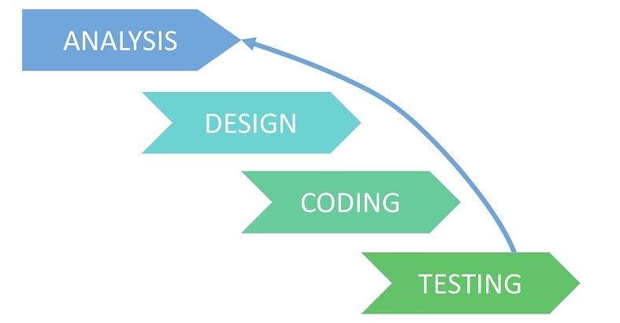

**Analysis:** Before a program is created, they have to know what they want to create. To understand the nature of the program to be built we must understand the information domain for the software as well as required function behavior, performance and interface requirements for both the system.

**Designing:** once the analysis is done now it’s time for designing. It is the process by which a person creates a specification of a software artifact, intended to accomplish goals, using a set of primitive components and subject to constraints. Software design usually involves problem solving and planning a software solution. This includes both low-level component and algorithm design and high-level, architecture design.

**Coding:** The design must be translated in machine readable form. It performs this task. If design is performed in a detailed manner, code generation can be accomplished mechanically.

**Testing:** once code has been generated, software testing begins. It is done before the release to the final audience. Software testing is meant to see how the software works under different conditions. Testing is done to understand if it will work correctly, partially fail to work properly, or totally fail to work properly. Each test may be used to see how one, or many, parts of the software work at a point in its development.

1. Prescriptive process models define a distinct set of activities, actions, tasks, milestones, and work products, that are required to engineer high-quality software. They do provide a useful roadmap for software engineering work.
2. We discuss here the strategy of the system development in detail as the Register and search Application is developed using this strategy.
3. The SDLC method is classically thought of as the set of activities that Analyst, designer and user carry out to develop and implement an information system. This method consists of six steps. In most business situations the activities are all closely related, usually inseparable and even order of the steps in these activities may be difficult to determine. Different parts of the project can be in various phases at the same time, with some components undergoing analysis while other is at advanced design stages.

**4.1 : Problem Definition:**

* Main Reason of developed this web application that is used to purchase online ordering of Kitchenware products.
* An online application that user can login properly and get view of different category and details of product.
* Whenever user can choice of different category FABRICS whatever he/she want to purchase then just add to the add to cart table.
* I had done this project using ASP.NET as front end and SQL Server as back end easing the effort of user.
* Modules of the Project
* **Administrators Module**
* The module will be protected by user ID and password. Ordinary users of the software will not be permitted to enter into this area of the software.
* The module will be focusing on the maintenance like Master Data Maintenance, Removal of old and outdated data from the software etc.
* **Client Side Module**
* This module will be protected by user ID and password as well. Ordinary users of the software will not be permitted to enter into this area of the software.
* The main purpose of this module is user can view product , add product to the add to cart , give feedback etc.

**4.2 : Requirement Analysis:**

Organization has following basic requirements to be performed by the website. So, user can be able to get following functionality from website.

* Information about online FABRICS ordering system.
* Information about different types of FABRICS ordering facility.
* Available range of different category FABRICS.
* Admin can add, update and delete all tables details.
* User able to put required information.
* User can do order different FABRICS category wise.
* User Can Update and View his Profile.
* Secure user Login account.
  1. **: About Existing Manual System:**
* If there is no website for a kitchenware products then the peoples have to go at the shops however they have no time for it.
* So it is waste of time for peoples who are very busy. After they go at the shop they confuse about the too much categories of the products.
* After that they buy the products what they want and pay the bill using cash, credit cards, etc…They receives the bill of the products which they purchase.
* So, using the billing system is the waste of paper. So, this is the existing manual system of our kitchenware products.

**4.4 : Feasibility Study:**

Feasibility is the measure of how beneficial or practical the development of information

The feasibility study involves following main criteria:

* Whether the identified user needs may be satisfied using current software and hardware technologies.
* The study will decide if the proposed system will be cost-effective and if it can be developed given existing budgetary constraints.
* Feasibility study should be cheap and quick.
* The result should inform the decision of whether to go ahead with a more detailed analysis.

**4.4.1 Technical Feasibility:**

It is a measure of the practicality of specific technical solution and the availability of technical resources and expertise. Technical feasibility is computer oriented.

* **Software requirement:**
* **Front end tool :**
* Microsoft Visual Studio 2010,2022
* Browser : Mozila, Firefox
* **Back end tool :**
* Microsoft SQL Server 2014
* **Hardware requirement:**
* 1.6 GHz or faster processor
* 2 GB RAM
* 32 Bit
* 250 GB HDD
* **Supported operating system**
* Windows 10,11
* Windows 7 (x86 and x64)
* Windows vista
* So that the database can reside on a control computer known as a **Server** and be shared among several users..

**Transact-SQL:-**SQL Server user Transact-SQL as its database query and programming language SQL is a set of commands that allows the user to specify the information to be retrieved or modified with Transact SQL. We can access data and query, update and manage relational database system.

**4.4.2 Operational Feasibility:**

It is a measure of how well the solution will work in the organization. It is also a measure of how people feel about the system/process. Operational feasibility is people oriented.

|  |  |  |  |
| --- | --- | --- | --- |
| Page | Process | Affected Table | Operation |
| 1.Product | Add,Updated,delete by admin | Product | Add,Update,Delete |
| 2.Registration | Update by user | Registration | Update |
| 3.Feedback | View And Delete by admin | Feedback | Delete |
| 4.Purchase | Add, Update  And Delete  By user | Purchase | Add, Update  And Delete |

**4.4.3 Economical Feasibility:**

It is a measure of the cost-effectiveness of a project or solution. This is often called a cost-benefit analysis. Economic feasibility deals with the costs and benefits of the information system.

|  |  |  |  |  |
| --- | --- | --- | --- | --- |
| Component | Minimum Requirement | Price | Local market Price | Website |
| 1.Processor | 1.6 GHz,  Intel Pentium | 1200 | 1400 | www.amazon.com |
| 2.Hardisk | 250GB | 2000 | 2100 | www.ebay.in |
| 3.Memory | 4GB RAM | 2000 | 2100 | [www.sanpdeal.com](http://www.sanpdeal.com) |
| 4.xampp | Free | Free | Free | www.ebey.com |

**Software Requirement**

|  |  |  |
| --- | --- | --- |
| Component | Price | Website |
| 1.Window 7 OS | 8199 or 10000 | www.Infibean.com |
| 2.Add of Photoshop 7.0 | 5000 | www.ebay.in |
| 3.Mozilla Firefox | Free | www.amazon.com |
| 4.Microsoft Visual Studio | Free | www.sanpdeal.com |

**4.5 Limitation of Existing System:**

* + Before we creating this web site, we were faces many problems
* People don’t know about our one storage of our website which is selling an every type of prodcuts.
  + So, people were purchase an products in different shop. So, their time is wasted.
  + We were gives a many advertisement in news paper & TV.

**4.6 Scope of the Proposed System:**

• This website has facility to view the purchase any products.

• User can also buy a many products.

• User can give feedback and ask some query to admin.

• Admin is authorized so while admin not approve user until user not login.

**5. Design**

DATA FLOW DIAGRAM

* **A Data Flow Diagram (DFD) is a graphical representation of the "flow" of data through an Information System.**
* A data flow diagram can also be used for the visualization of Data Processing. It is common practice for a designer to draw a context-level DFD first which shows the interaction between the system and outside entities.

|  |  |  |
| --- | --- | --- |
| **DFD Symbols Description** | | |
| **Symbol Name** | **Shape** | **Description** |
| **External Entity** |  | The sharp cornered rectangles(or simply boxes) in a DFD indicates entities.  Entities are people things, organizations etc. |
| **Process** |  | The Process symbol represents an activity that transforms or manipulates the data (combines, reorders, converts, etc.). |
| **Data Store** | Untitled | Opened sided rectangles in DFD indicates data store.  A Data Store is a repository of data. |
| **DataF low** |  | Arrow symbol in DFD indicate data flow.  The Data Flow symbol represents movement of data |

* **Functional Modeling:-**

**Data Flow Diagram**

**(1)DFD for 0 levels**



**(2)DFD for 1 level**



**(3)DFD for 2 levels**



**5.1 Object Oriented Approach:**

**5.1.1 Use case Diagrams:**

**Use case diagram for Admin:**



**Use case diagram for Client:**

**5.1.2 Activity Diagrams:**

**Activity Diagram for Invalid User:**





**Activity Diagram for Admin:**

**5.2 Traditional Approach**

**5.2.2 ER Diagrams:**



**5.2.3 Data Dictionary:**

**1. Login:-**

|  |  |  |
| --- | --- | --- |
| **Attributes** | **Type** | **Description** |
| Id | Int | Auto Increment |
| Username | Varchar(50) | Null |
| Password | Varchar(50) | Null |

**2. Registration:-**

|  |  |  |
| --- | --- | --- |
| **Attributes** | **Type** | **Description** |
| Id | Int | Auto Increment |
| Name | Varchar(50) | Null |
| Address | Text | Null |
| City | Varchar(20) | Null |
| Pincode | Varchar(20) | Null |
| State | Varchar(20) | Null |
| Username | Varchar(50) | Null |
| Password | Varchar(20) | Null |
| Gender | Varchar(20) | Null |
| Mobile | Varchar(20) | Null |
| Email | Varchar(50) | Null |
| Dob | Varchar(50) | Null |

**3. Product:-**

|  |  |  |
| --- | --- | --- |
| **Attributes** | **Type** | **Description** |
| Id | Int | Auto Increment |
| Name | Varchar(50) | Null |
| Category | Varchar(50) | Null |
| Price | Varchar(50) | Null |
| Image | Varchar(250) | Null |
| Description | Text | Null |

**4. Purchase:-**

|  |  |  |
| --- | --- | --- |
| **Attributes** | **Type** | **Description** |
| Id | Int | Auto Increment |
| Name | Varchar(50) | Null |
| Price | int | Null |
| Quantity | int | Null |
| Username | Varchar(50) | Null |
| Total | Int | Null |

**5. Feedback:-**

|  |  |  |
| --- | --- | --- |
| **Attributes** | **Type** | **Description** |
| Id | Int | Auto Increment |
| Name | Varchar(50) | Null |
| Mobile | Varchar(50) | Null |
| Email | Varchar(50) | Null |
| Feedback | Text | Null |

**6. Add to Cart:-**

|  |  |  |
| --- | --- | --- |
| **Attributes** | **Type** | **Description** |
| Id | Int | Auto Increment |
| Name | Varchar(50) | Null |
| Price | Int | Null |
| Quantity | int | Null |
| Image | Varchar(MAX) | Null |
| Username | Varchar(50) | Null |
| Total | int | Null |

1. **Implementation & Planning**

**6.1 Gantt Chart:**

|  |  |  |  |  |  |  |  |  |  |  |  |  |  |  |  |  |
| --- | --- | --- | --- | --- | --- | --- | --- | --- | --- | --- | --- | --- | --- | --- | --- | --- |
| ID | Task Name | Start | Finish | Duration | Nov-2024 | Dec-2024 | | | Jan-2025 | | | Feb-2025 | | | | |
| 25- Nov | 15- Dec | 16-Dec | 31 Dec | 01-Jan | 10-Jan | 11-Jan | 11-Feb | 12-Feb | 20-Feb | 21-Feb | 28-Feb |
| 1 | Requirements Analysis | 25-11-2024 | 15-12-2024 | 3wk |  | |  | | | | | | | | | |
| 2 | Database design | 16-12-2024 | 31-12-2024 | 2wk 2d |  | |  | |  | | | | | | | |
| 3 | Screen design | 01-01-2025 | 10-01-2025 | 1wk 4d |  | | | |  | |  | | | | | |
| 4 | Programming | 11-01-2025 | 11-02-2025 | 4wk 4d |  | | | | | |  | |  | | | |
| 5 | Testing | 12-02-2025 | 20-02-2025 | 9d |  | | | | | | | |  | |  | | |
| 6 | User documentation | 21-02-2025 | 28-02-2025 | 8d |  | | | | | | | | | |  | |

**7. Input & Output Design:**

**7.1 Screen layouts:**

**Admin:**

**AdminMasterPage.master:-**

<%@ Master Language="C#" AutoEventWireup="true" CodeFile="AdminMasterPage.master.cs" Inherits="Admin_Admin1MasterPage" %>

<!DOCTYPE html PUBLIC "-//W3C//DTD XHTML 1.0 Transitional//EN" "http://www.w3.org/TR/xhtml1/DTD/xhtml1-transitional.dtd">

<html xmlns="http://www.w3.org/1999/xhtml">

<head runat="server">

<title></title>

<asp:ContentPlaceHolder id="head" runat="server">

</asp:ContentPlaceHolder>

</head>

<body style="background-image:url('images/bg.jpg');">

<form id="form1" runat="server">

<div>

<head>

<meta charset="utf-8">

<meta name="viewport" content="width=device-width, initial-scale=1">

<meta name="description" content="">

<meta name="author" content="">

<title>Radhika Fabric</title>

<!-- CSS FILES -->

<link rel="preconnect" href="https://fonts.googleapis.com">

<link rel="preconnect" href="https://fonts.gstatic.com" crossorigin>

<link href="https://fonts.googleapis.com/css2?family=Inter:wght@100;300;400;700;900&display=swap" rel="stylesheet">

<link href="css/bootstrap.min.css" rel="stylesheet">

<link href="css/bootstrap-icons.css" rel="stylesheet">

<link rel="stylesheet" href="css/slick.css"/>

<link href="css/tooplate-little-fashion.css" rel="stylesheet">

</head>

<main>

<nav class="navbar navbar-expand-lg">

<div class="container">

<button class="navbar-toggler" type="button" data-bs-toggle="collapse" data-bs-target="#navbarNav" aria-controls="navbarNav" aria-expanded="false" aria-label="Toggle navigation">

<span class="navbar-toggler-icon"></span>

</button>

<a class="navbar-brand" href="Home.aspx">

<strong><span>Radhika</span> Fabric</strong>

</a>

<div class="d-lg-none">

<a href="sign-in.html" class="bi-person custom-icon me-3"></a>

<a href="product-detail.html" class="bi-bag custom-icon"></a>

</div>

</div>

</nav>

</main>

<asp:ContentPlaceHolder id="ContentPlaceHolder1" runat="server">

</asp:ContentPlaceHolder>

<footer class="site-footer">

<div class="container">

<div class="row">

<div class="col-lg-3 col-10 me-auto mb-1">

<h4 class="text-white mb-2"><a href="home.aspx">Radhika</a> Fabric</h4>

<p class="copyright-text text-muted mt-lg-5 mb-4 mb-lg-0">Copyright © 2024 <strong>Radhika Fabric</strong></p>

<br>

<p class="copyright-text">Designed by <a href="" target="_blank">Radhika Fabric</a></p>

</div>

<div class="col-lg-5 col-8">

<h5 class="text-white mb-3">Sitemap</h5>

<ul class="footer-menu d-flex flex-wrap">

<li class="footer-menu-item"><a href="#" class="footer-menu-link">About</a></li>

<li class="footer-menu-item"><a href="#" class="footer-menu-link">Products</a></li>

<li class="footer-menu-item"><a href="#" class="footer-menu-link">Feedback</a></li>

<li class="footer-menu-item"><a href="#" class="footer-menu-link">Contact</a></li>

</ul>

</div>

<div class="col-lg-3 col-4">

<h5 class="text-white mb-3">Social</h5>

<ul class="social-icon">

<li><a href="#" class="social-icon-link bi-youtube"></a></li>

<li><a href="#" class="social-icon-link bi-whatsapp"></a></li>

<li><a href="#" class="social-icon-link bi-instagram"></a></li>

<li><a href="#" class="social-icon-link bi-skype"></a></li>

</ul>

</div>

</div>

</div>

</footer>

<!-- JAVASCRIPT FILES -->

<script src="js/jquery.min.js"></script>

<script src="js/bootstrap.bundle.min.js"></script>

<script src="js/Headroom.js"></script>

<script src="js/jQuery.headroom.js"></script>

<script src="js/slick.min.js"></script>

<script src="js/custom.js"></script>

</div>

</form>

</body>

</html>

**Login.aspx :-**

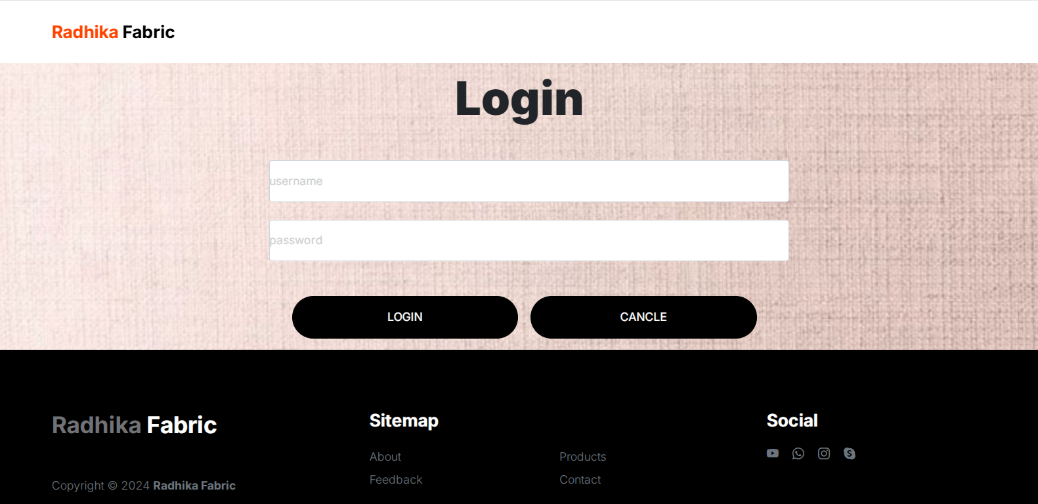

**Login.aspx.cs:-**

using System;

using System.Collections.Generic;

using System.Linq;

using System.Web;

using System.Web.UI;

using System.Web.UI.WebControls;

using System.Data;

using System.Web.Configuration;

using System.Data.SqlClient;

public partial class Admin_login : System.Web.UI.Page

{

SqlConnection con = new SqlConnection();

SqlCommand cmd;

protected void Page_Load(object sender, EventArgs e)

{

con.ConnectionString = WebConfigurationManager.ConnectionStrings["ConnectionString"].ConnectionString;

con.Open();

}

protected void btnlogin_Click(object sender, EventArgs e)

{

DataTable dt = new DataTable();

SqlDataAdapter da = new SqlDataAdapter("select * from login where username='" + txtuname.Text + "'and password='" + txtpass.Text + "'", con);

da.Fill(dt);

if (dt.Rows.Count == 0)

{

Response.Write("<script>alert('your username or password is wrong'); window.location.href='login.aspx';</script>");

}

else

{

Session["uname"] = txtuname.Text;

Response.Redirect("home.aspx");

}

}

protected void btncancle_Click(object sender, EventArgs e)

{

Response.Redirect("login.aspx");

}

}

**Home.aspx**

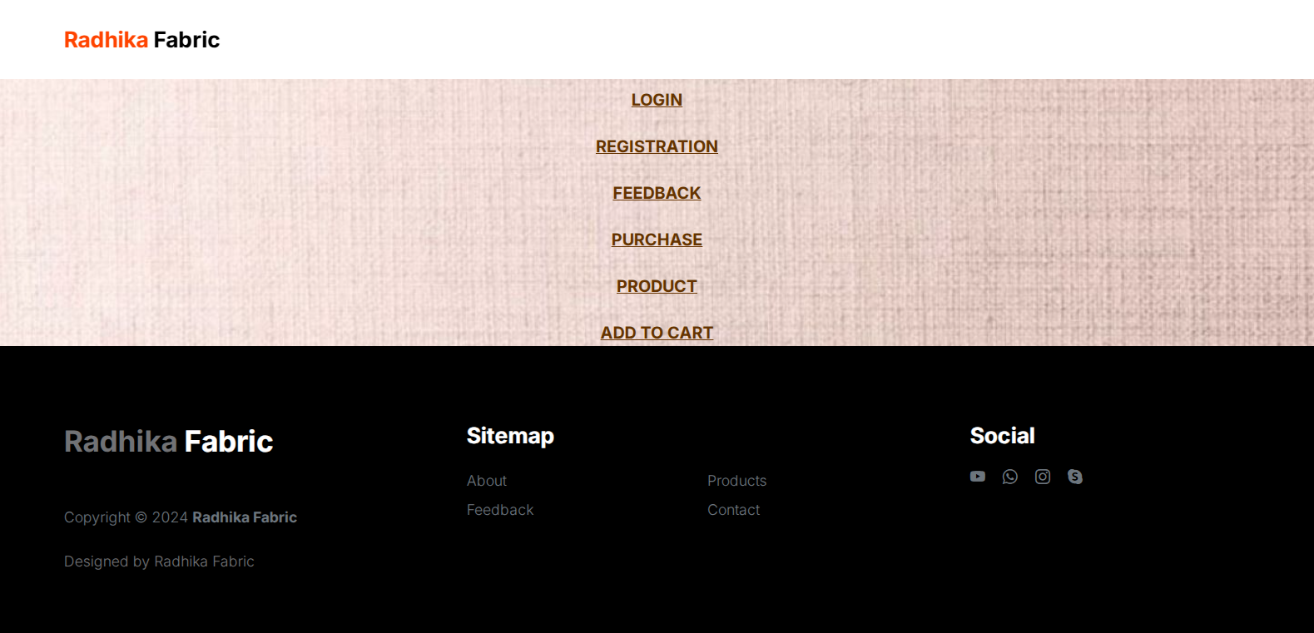

<%@ Page Title="" Language="C#" MasterPageFile="~/Admin/AdminMasterPage.master" AutoEventWireup="true" CodeFile="home.aspx.cs" Inherits="Admin_home" %>

<asp:Content ID="Content1" ContentPlaceHolderID="head" Runat="Server">

</asp:Content>

<asp:Content ID="Content2" ContentPlaceHolderID="ContentPlaceHolder1" Runat="Server">

<br />

<br />

<br />

<br />

<center>

<asp:HyperLink ID="HyperLink1" runat="server"

NavigateUrl="~/Admin/loginmaster.aspx" Font-Bold="True" Font-Size="Large"

Font-Underline="True" ForeColor="#663300" >LOGIN</asp:HyperLink>

<br />

<br />

<asp:HyperLink ID="HyperLink2" runat="server"

NavigateUrl="~/Admin/registrationmaster.aspx" Font-Bold="True"

Font-Size="Large" Font-Underline="True" ForeColor="#663300">REGISTRATION</asp:HyperLink>

<br />

<br />

<asp:HyperLink ID="HyperLink3" runat="server"

NavigateUrl="~/Admin/feedbackmaster.aspx" Font-Bold="True"

Font-Size="Large" Font-Underline="True" ForeColor="#663300">FEEDBACK</asp:HyperLink>

<br />

<br />

<asp:HyperLink ID="HyperLink4" runat="server" Font-Bold="True"

Font-Size="Large" Font-Underline="True" ForeColor="#663300"

NavigateUrl="~/Admin/purchasemaster.aspx">PURCHASE</asp:HyperLink>

<br />

<br />

<asp:HyperLink ID="HyperLink5" runat="server" Font-Bold="True"

Font-Size="Large" Font-Underline="True" ForeColor="#663300"

NavigateUrl="~/Admin/productmaster.aspx">PRODUCT</asp:HyperLink>

<br />

<br />

<asp:HyperLink ID="HyperLink6" runat="server" Font-Bold="True"

Font-Size="Large" Font-Underline="True" ForeColor="#663300"

NavigateUrl="~/Admin/addtocart.aspx">ADD TO CART</asp:HyperLink>

<br />

</center>

</asp:Content>

**Loginmaster.aspx**

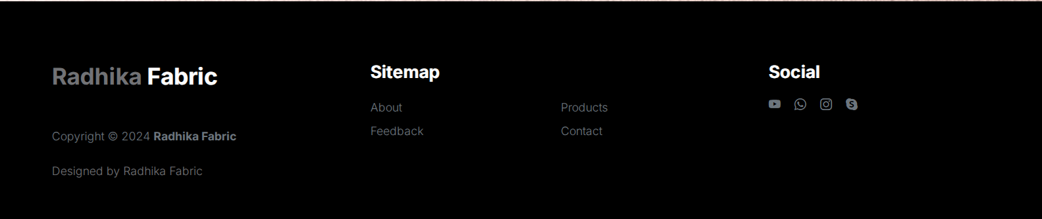

**Loginmaster.cs**

using System;

using System.Collections.Generic;

using System.Linq;

using System.Web;

using System.Web.UI;

using System.Web.UI.WebControls;

using System.Data.SqlClient;

using System.Data;

using System.Web.Configuration;

public partial class Admin_loginmaster : System.Web.UI.Page

{

SqlConnection con = new SqlConnection();

SqlDataAdapter da = new SqlDataAdapter();

static DataSet ds = new DataSet();

public void refdata()

{

ds.Clear();

da = new SqlDataAdapter("select * from login", con);

da.Fill(ds);

}

public void binddata()

{

GridView1.DataBind();

}

protected void Page_Load(object sender, EventArgs e)

{

con.ConnectionString = WebConfigurationManager.ConnectionStrings["ConnectionString"].ConnectionString;

con.Open();

if (Session["uname"] == null)

{

Response.Redirect("loginmaster.aspx");

}

if (!IsPostBack)

{

refdata();

binddata();

}

}

protected void btninsert_Click(object sender, EventArgs e)

{

Response.Redirect("logininsert.aspx");

}

}

**Logininsert.aspx**

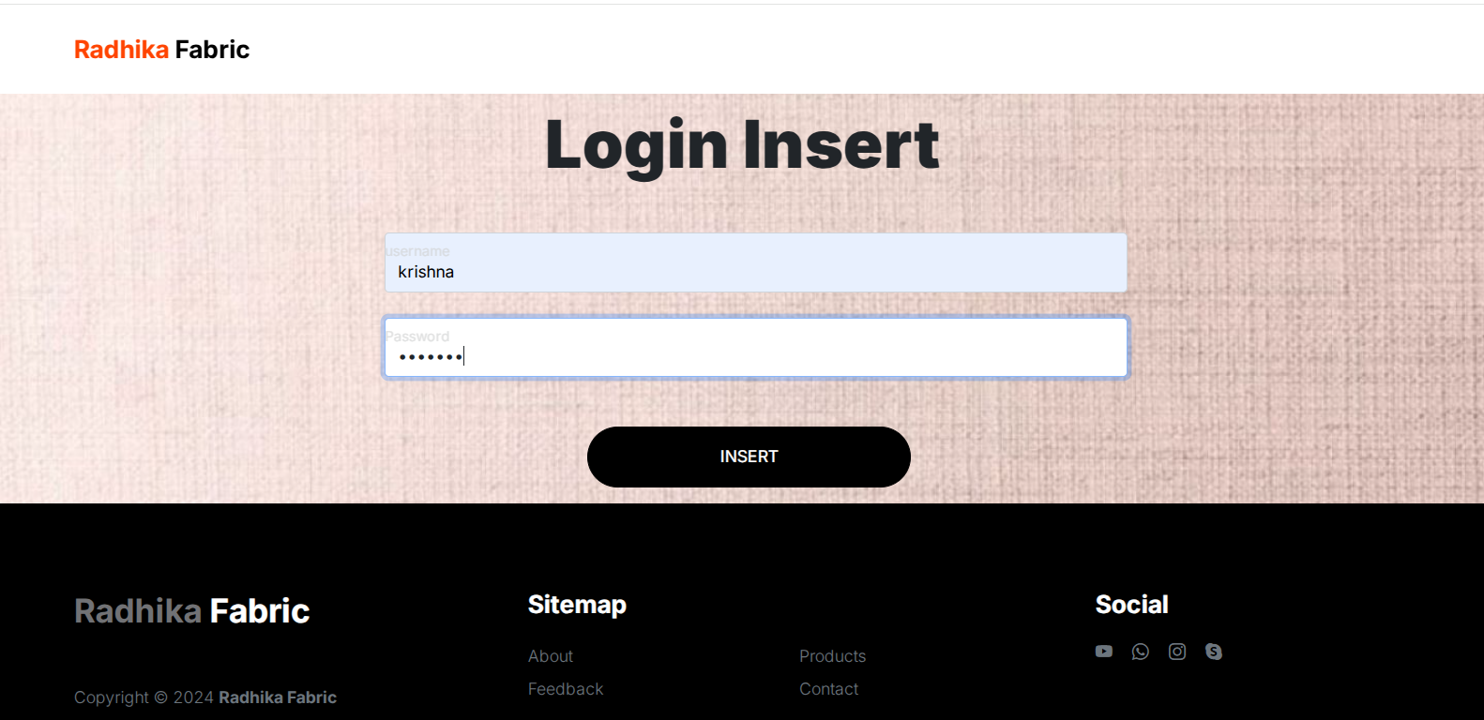

**Logininsert.cs:**

using System;

using System.Collections.Generic;

using System.Linq;

using System.Web;

using System.Web.UI;

using System.Web.UI.WebControls;

using System.Data.SqlClient;

using System.Data;

using System.Web.Configuration;

using System.Windows.Forms;

public partial class Admin_logininsert : System.Web.UI.Page

{

SqlConnection con = new SqlConnection();

int result = 0;

protected void Page_Load(object sender, EventArgs e)

{

con.ConnectionString = WebConfigurationManager.ConnectionStrings["ConnectionString"].ConnectionString;

con.Open();

if (Session["uname"] == null)

{

Response.Redirect("login.aspx");

}

}

protected void btninsert_Click(object sender, EventArgs e)

{

SqlCommand cmd = new SqlCommand("insert into login values(@name,@pass)", con);

cmd.Parameters.AddWithValue("@name", txtuname.Text);

cmd.Parameters.AddWithValue("@pass", txtpass.Text);

result = cmd.ExecuteNonQuery();

if (result == 0)

{

Response.Write("<script>alert('Not inserted'); window.location.href='loginmaster.aspx';</script>");

}

else

{

Response.Redirect("loginmaster.aspx");

}

con.Close();

}

}

**Loginupdate.aspx**

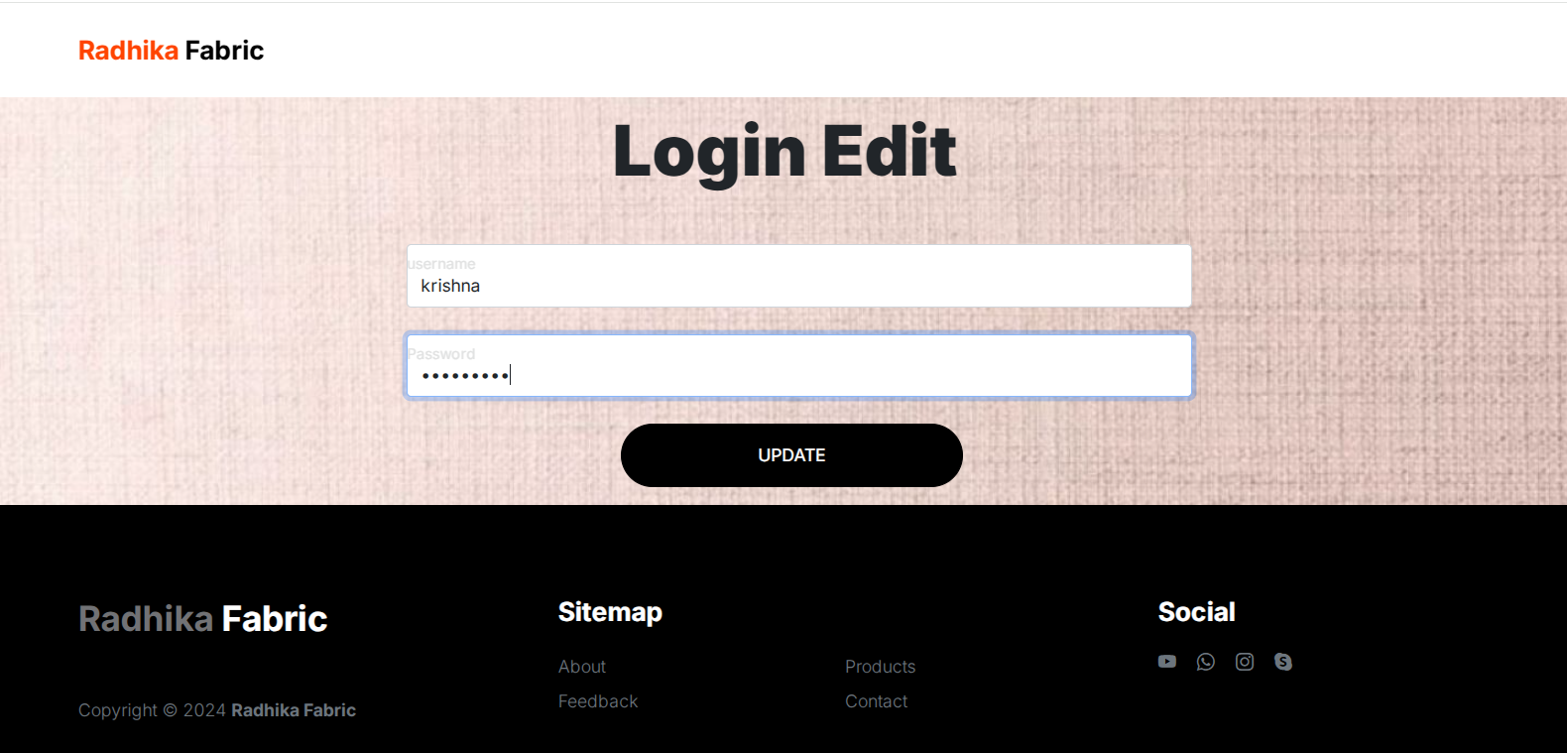

**Loginupdate.cs**

using System;

using System.Collections.Generic;

using System.Linq;

using System.Web;

using System.Web.UI;

using System.Web.UI.WebControls;

using System.Data.SqlClient;

using System.Data;

using System.Web.Configuration;

using System.Windows.Forms;

public partial class Admin_loginedit : System.Web.UI.Page

{

SqlConnection con = new SqlConnection();

SqlCommand cmd;

static DataSet ds = new DataSet();

SqlDataAdapter da;

int res = 0;

public void refdata()

{

string id = Request.QueryString["id"];

if (id == null)

{

Response.Redirect("loginmaster.aspx");

}

ds.Clear();

da = new SqlDataAdapter("select * from login where id=" + id, con);

da.Fill(ds);

}

public void showdata()

{

txtuname.Text = ds.Tables[0].Rows[0]["username"].ToString();

txtpass.Text = ds.Tables[0].Rows[0]["password"].ToString();

}

protected void Page_Load(object sender, EventArgs e)

{

con.ConnectionString = WebConfigurationManager.ConnectionStrings["ConnectionString"].ConnectionString;

con.Open();

if (Session["uname"] == null)

{

Response.Redirect("login.aspx");

}

if (!IsPostBack)

{

refdata();

showdata();

}

}

protected void btnloginedit_Click(object sender, EventArgs e)

{

string id = Request.QueryString["id"];

cmd = new SqlCommand("update login set username=@username,password=@password where id=" + id, con);

cmd.Parameters.AddWithValue("@username", txtuname.Text);

cmd.Parameters.AddWithValue("@password", txtpass.Text);

res = cmd.ExecuteNonQuery();

if (res == 0)

{

Response.Write("<script>alert('Not deleted'); window.location.href='loginmaster.aspx';</script>");

}

else

{

Response.Redirect("login.aspx");

}

con.Close();

}

}

**Logindelete.cs**

using System;

using System.Collections.Generic;

using System.Linq;

using System.Web;

using System.Web.UI;

using System.Web.UI.WebControls;

using System.Data.SqlClient;

using System.Data;

using System.Web.Configuration;

using System.Windows.Forms;

public partial class Admin_logindelete : System.Web.UI.Page

{

SqlConnection con = new SqlConnection();

SqlCommand cmd;

int res = 0;

protected void Page_Load(object sender, EventArgs e)

{

con.ConnectionString = WebConfigurationManager.ConnectionStrings["ConnectionString"].ConnectionString;

con.Open();

if (Session["uname"] == null)

{

Response.Redirect("login.aspx");

}

string id = Request.QueryString["id"];

if (id == null)

{

Response.Redirect("loginmaster.aspx");

}

cmd = new SqlCommand("delete from login where id=" + id, con);

res = cmd.ExecuteNonQuery();

if (res == 0)

{

Response.Write("<script>alert('Not deleted'); window.location.href='loginmaster.aspx';</script>");

}

else

{

Response.Redirect("login.aspx");

}

con.Close();

}

}

**RegistrationMaster.aspx**

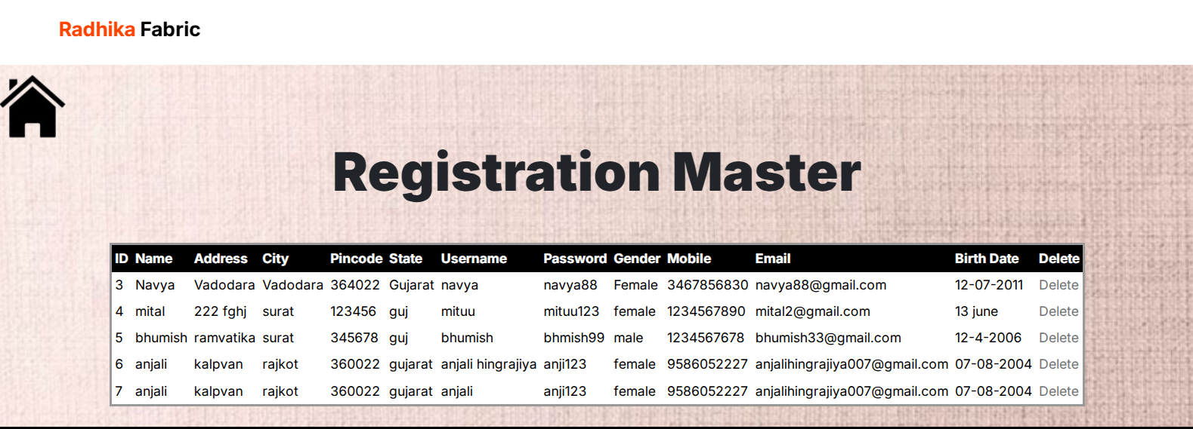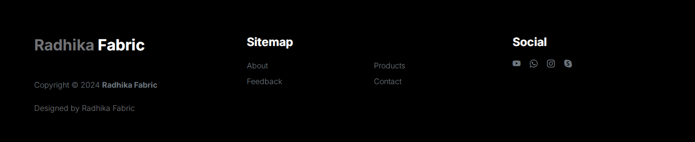

**RegistrationMaster.cs**

using System;

using System.Collections.Generic;

using System.Linq;

using System.Web;

using System.Web.UI;

using System.Web.UI.WebControls;

using System.Data.SqlClient;

using System.Data;

using System.Web.Configuration;

public partial class Admin_registrationmaster : System.Web.UI.Page

{

SqlConnection con = new SqlConnection();

SqlDataAdapter da = new SqlDataAdapter();

static DataSet ds = new DataSet();

public void refdata()

{

ds.Clear();

da = new SqlDataAdapter("select * from registration", con);

da.Fill(ds);

}

public void binddata()

{

GridView1.DataBind();

}

protected void Page_Load(object sender, EventArgs e)

{

con.ConnectionString = WebConfigurationManager.ConnectionStrings["ConnectionString"].ConnectionString;

con.Open();

if (Session["uname"] == null)

{

Response.Redirect("login.aspx");

}

if (!IsPostBack)

{

refdata();

binddata();

}

}

}

**Registrationdelete.cs**

using System;

using System.Collections.Generic;

using System.Linq;

using System.Web;

using System.Web.UI;

using System.Web.UI.WebControls;

using System.Web.Configuration;

using System.Data;

using System.Data.SqlClient;

public partial class Admin_registrationdelete : System.Web.UI.Page

{

SqlConnection con = new SqlConnection();

SqlCommand cmd;

int res = 0;

protected void Page_Load(object sender, EventArgs e)

{

con.ConnectionString = WebConfigurationManager.ConnectionStrings["ConnectionString"].ConnectionString;

con.Open();

if (Session["uname"] == null)

{

Response.Redirect("login.aspx");

}

string id = Request.QueryString["id"];

if (id == null)

{

Response.Redirect("registrationmaster.aspx");

}

cmd = new SqlCommand("delete from registration where id=" + id, con);

res = cmd.ExecuteNonQuery();

if (res == 0)

{

Response.Write("<script>alert('Not deleted'); window.location.href='registrationmaster.aspx';</script>");

}

else

{

Response.Redirect("registrationmaster.aspx");

}

con.Close();

}

}

**FeedbackMaster.aspx**

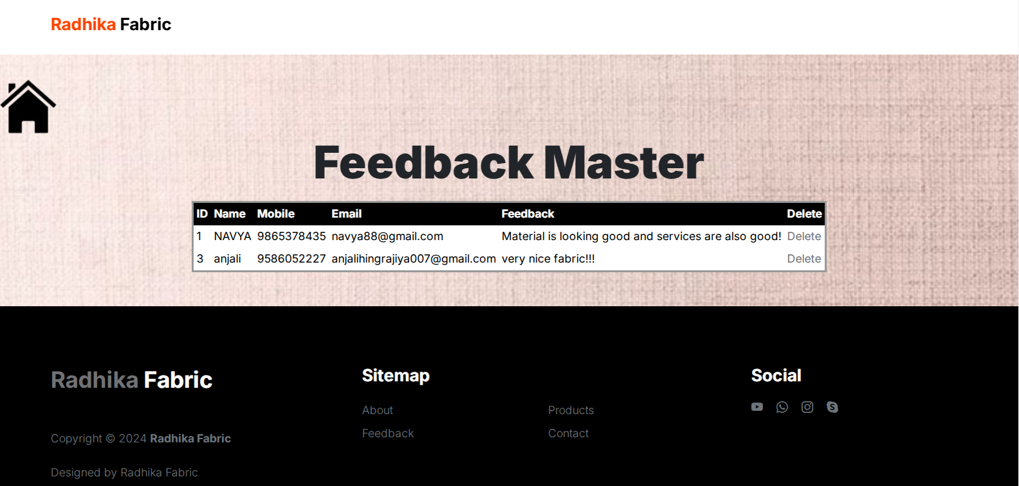

**FeedbackMaster.cs**

using System;

using System.Collections.Generic;

using System.Linq;

using System.Web;

using System.Web.UI;

using System.Web.UI.WebControls;

using System.Data.SqlClient;

using System.Web.Configuration;

using System.Data;

public partial class Admin_feedbackmaster : System.Web.UI.Page

{

SqlConnection con = new SqlConnection();

SqlDataAdapter da = new SqlDataAdapter();

static DataSet ds = new DataSet();

public void refdata()

{

ds.Clear();

da = new SqlDataAdapter("select * from feedback", con);

da.Fill(ds);

}

public void binddata()

{

GridView1.DataBind();

}

protected void Page_Load(object sender, EventArgs e)

{

con.ConnectionString = WebConfigurationManager.ConnectionStrings["ConnectionString"].ConnectionString;

con.Open();

if (Session["uname"] == null)

{

Response.Redirect("login.aspx");

}

if (!IsPostBack)

{

refdata();

binddata();

}

}

}

**Feedbackdelete.cs**

using System;

using System.Collections.Generic;

using System.Linq;

using System.Web;

using System.Web.UI;

using System.Web.UI.WebControls;

using System.Data;

using System.Data.SqlClient;

using System.Web.Configuration;

public partial class Admin_feedbackdelete : System.Web.UI.Page

{

SqlConnection con = new SqlConnection();

SqlCommand cmd;

int res = 0;

protected void Page_Load(object sender, EventArgs e)

{

con.ConnectionString = WebConfigurationManager.ConnectionStrings["ConnectionString"].ConnectionString;

con.Open();

if (Session["uname"] == null)

{

Response.Redirect("login.aspx");

}

string id = Request.QueryString["id"];

if (id == null)

{

Response.Redirect("feedbackmaster.aspx");

}

cmd = new SqlCommand("delete from feedback where id=" + id, con);

res = cmd.ExecuteNonQuery();

if (res == 0)

{

Response.Write("<script>alert('Not deleted'); window.location.href='feedbackmaster.aspx';</script>");

}

else

{

Response.Redirect("feedbackmaster.aspx");

}

con.Close();

}

}

**PurchaseMaster.aspx**

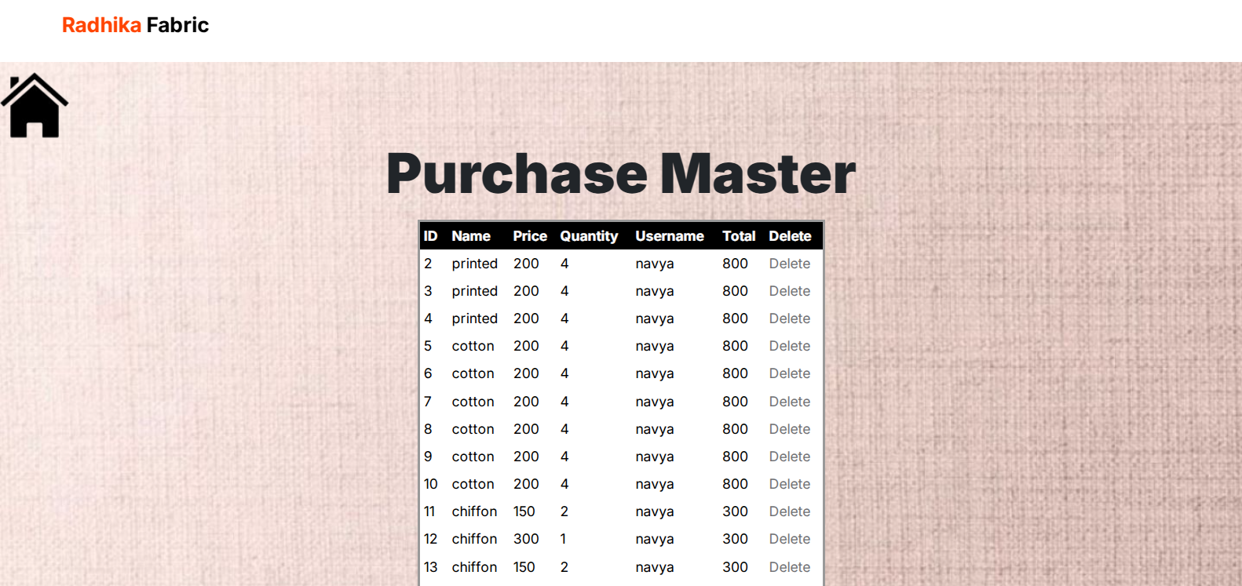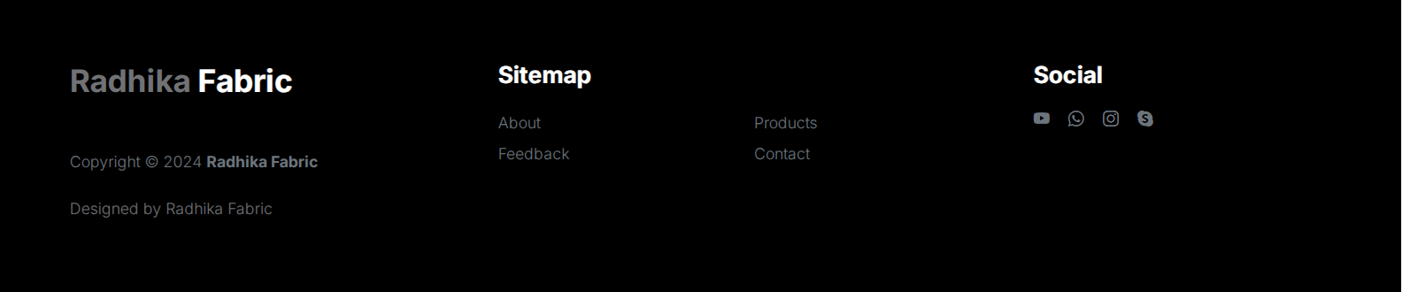

**PurchaseMaster.cs**

**PurchaseDelete.cs**

using System;

using System.Collections.Generic;

using System.Linq;

using System.Web;

using System.Web.UI;

using System.Web.UI.WebControls;

using System.Data;

using System.Data.SqlClient;

using System.Web.Configuration;

public partial class Admin_purchasedelete : System.Web.UI.Page

{

SqlConnection con = new SqlConnection();

SqlCommand cmd;

int res = 0;

protected void Page_Load(object sender, EventArgs e)

{

con.ConnectionString = WebConfigurationManager.ConnectionStrings["ConnectionString"].ConnectionString;

con.Open();

if (Session["uname"] == null)

{

Response.Redirect("login.aspx");

}

string id = Request.QueryString["id"];

if (id == null)

{

Response.Redirect("purchasemaster.aspx");

}

cmd = new SqlCommand("delete from purchase where id=" + id, con);

res = cmd.ExecuteNonQuery();

if (res == 0)

{

Response.Write("<script>alert('Not deleted'); window.location.href='purchasemaster.aspx';</script>");

}

else

{

Response.Redirect("purchasemaster.aspx");

}

con.Close();

}

}

**ProductMaster.aspx:**

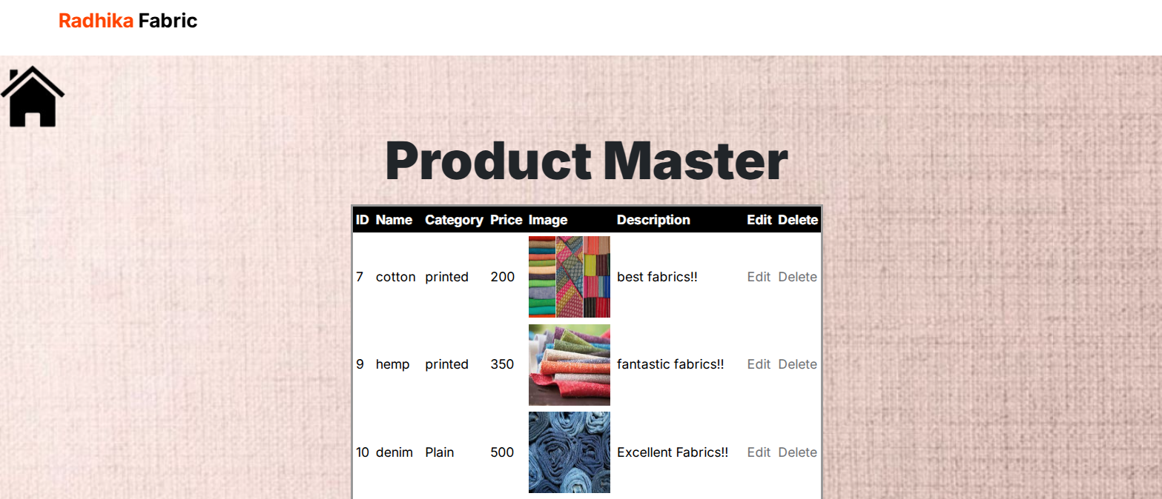

**ProductMaster.cs**

using System;

using System.Collections.Generic;

using System.Linq;

using System.Web;

using System.Web.UI;

using System.Web.UI.WebControls;

using System.Data.SqlClient;

using System.Web.Configuration;

using System.Data;

public partial class Admin_productmaster : System.Web.UI.Page

{

SqlConnection con = new SqlConnection();

SqlDataAdapter da = new SqlDataAdapter();

static DataSet ds = new DataSet();

public void refdata()

{

ds.Clear();

da = new SqlDataAdapter("select * from product", con);

da.Fill(ds);

}

public void binddata()

{

GridView1.DataBind();

}

protected void Page_Load(object sender, EventArgs e)

{

con.ConnectionString = WebConfigurationManager.ConnectionStrings["ConnectionString"].ConnectionString;

con.Open();

if (Session["uname"] == null)

{

Response.Redirect("login.aspx");

}

if (!IsPostBack)

{

refdata();

binddata();

}

}

protected void btninsert_Click(object sender, EventArgs e)

{

Response.Redirect("productinsert.aspx");

}

}

**Productinsert.aspx**

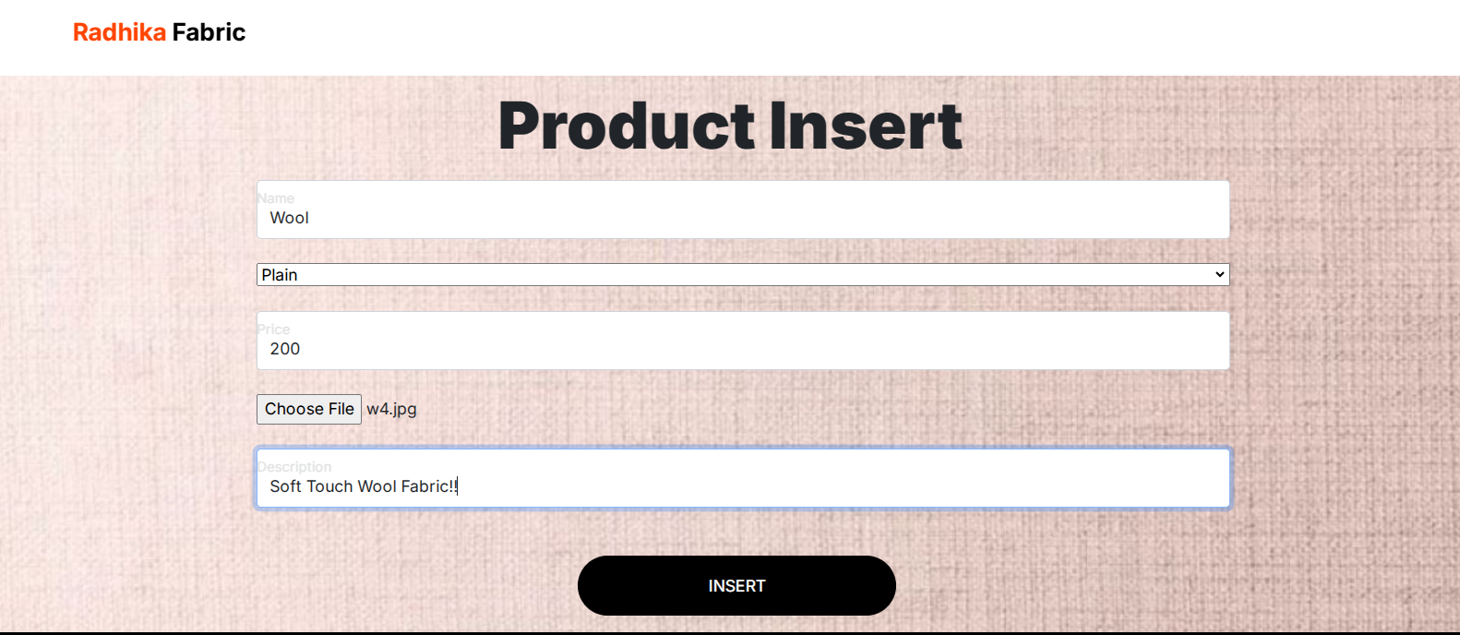

**Productinsert.cs**

using System;

using System.Collections.Generic;

using System.Linq;

using System.Web;

using System.Web.UI;

using System.Web.UI.WebControls;

using System.Data.SqlClient;

using System.Data;

using System.Web.Configuration;

public partial class Admin_productinsert : System.Web.UI.Page

{

SqlConnection con = new SqlConnection();

int res = 0;

protected void Page_Load(object sender, EventArgs e)

{

con.ConnectionString = WebConfigurationManager.ConnectionStrings["ConnectionString"].ConnectionString;

con.Open();

if (Session["uname"] == null)

{

Response.Redirect("login.aspx");

}

if (!IsPostBack)

{

binddropdownlist();

}

}

protected void btninsert_Click(object sender, EventArgs e)

{

SqlCommand cmd = new SqlCommand("insert into product values(@name,@category,@price,@image,@description)", con);

cmd.Parameters.AddWithValue("@name", txtname.Text);

cmd.Parameters.AddWithValue("@category", DropDownList1.Text);

cmd.Parameters.AddWithValue("@price", txtprice.Text);

cmd.Parameters.AddWithValue("@image", FileUpload1.FileName);

String path = Server.MapPath("~/admin/product/");

FileUpload1.SaveAs(path + FileUpload1.FileName);

cmd.Parameters.AddWithValue("@description", txtdes.Text);

res = cmd.ExecuteNonQuery();

if (res == 0)

{

Response.Write("<script>alert('Not inserted'); window.location.href='productmaster.aspx';</script>");

}

else

{

Response.Redirect("productmaster.aspx");

}

}

private void binddropdownlist()

{

string query = "select * from category";

SqlDataAdapter sd = new SqlDataAdapter(query,con);

DataTable dt = new DataTable();

sd.Fill(dt);

DropDownList1.DataSource = dt;

DropDownList1.DataTextField = "catname";

DropDownList1.DataValueField = "catid";

DropDownList1.Items.Insert(0, new ListItem("select category", "0"));

}

}

**ProductEdit.aspx**

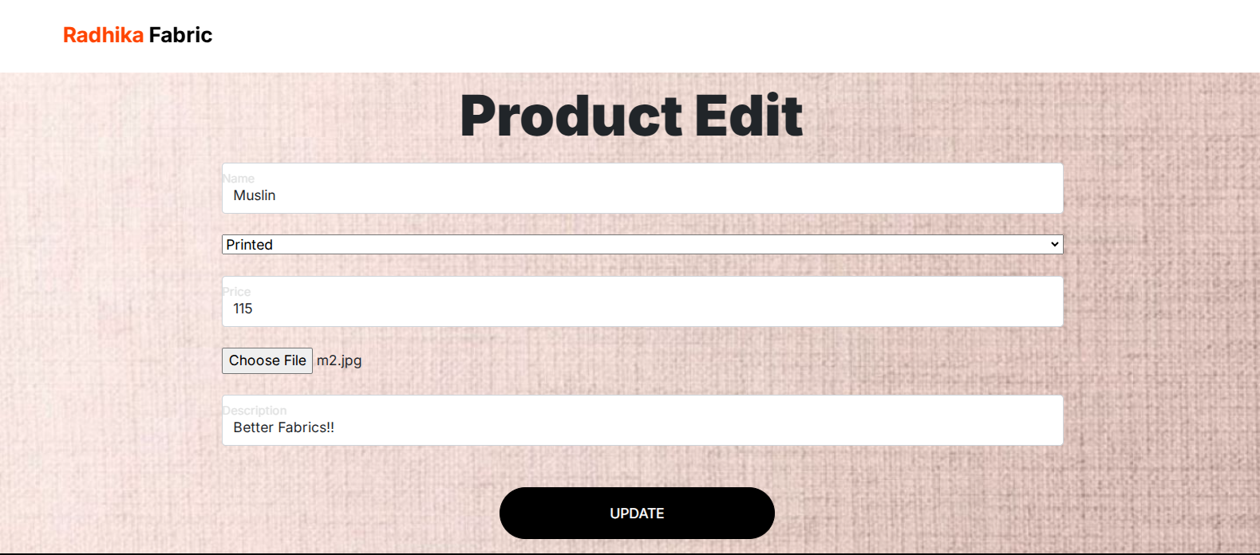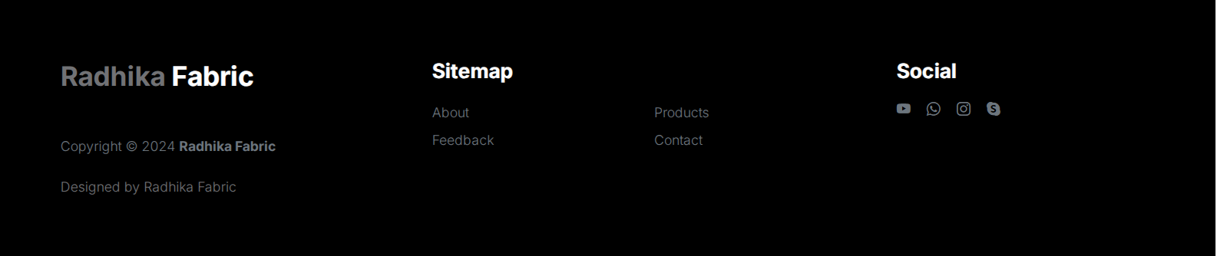

**ProductEdit.cs**

using System;

using System.Collections.Generic;

using System.Linq;

using System.Web;

using System.Web.UI;

using System.Web.UI.WebControls;

using System.Data;

using System.Data.SqlClient;

using System.Web.Configuration;

public partial class Admin_productedit : System.Web.UI.Page

{

SqlConnection con = new SqlConnection();

SqlCommand cmd;

static DataSet ds = new DataSet();

SqlDataAdapter da;

int res = 0;

public void refdata()

{

string id = Request.QueryString["id"];

if (id == null)

{

Response.Redirect("login.aspx");

}

ds.Clear();

da = new SqlDataAdapter("select * from product where id=" + id, con);

da.Fill(ds);

}

public void showdata()

{

txtname.Text = ds.Tables[0].Rows[0]["name"].ToString();

DropDownList1.Text = ds.Tables[0].Rows[0]["category"].ToString();

txtprice.Text = ds.Tables[0].Rows[0]["price"].ToString();

txtdes.Text = ds.Tables[0].Rows[0]["description"].ToString();

}

protected void Page_Load(object sender, EventArgs e)

{

con.ConnectionString = WebConfigurationManager.ConnectionStrings["ConnectionString"].ConnectionString;

con.Open();

if (Session["uname"] == null)

{

Response.Redirect("productmaster.aspx");

}

if (!IsPostBack)

{

refdata();

showdata();

binddropdownlist();

}

}

private void binddropdownlist()

{

string query = "select * from category";

SqlDataAdapter sd = new SqlDataAdapter(query, con);

DataTable dt = new DataTable();

sd.Fill(dt);

DropDownList1.DataSource = dt;

DropDownList1.DataTextField = "catname";

DropDownList1.DataValueField = "catid";

DropDownList1.Items.Insert(0, new ListItem("select category", "0"));

}

protected void btnupdate_Click(object sender, EventArgs e)

{

if (FileUpload1.HasFile)

{

string id = Request.QueryString["id"];

cmd = new SqlCommand("update product set name=@name,category=@category,price=@price,image=@image,description=@description where id=" + id, con);

cmd.Parameters.AddWithValue("@name", txtname.Text);

cmd.Parameters.AddWithValue("@category", DropDownList1.Text);

cmd.Parameters.AddWithValue("@price", txtprice.Text);

cmd.Parameters.AddWithValue("@image", FileUpload1.FileName);

String path = Server.MapPath("~/admin/product/");

FileUpload1.SaveAs(path + FileUpload1.FileName);

cmd.Parameters.AddWithValue("@description", txtdes.Text);

res = cmd.ExecuteNonQuery();

if (res == 0)

{

Response.Write("<script>alert('Not edited'); window.location.href='productmaster.aspx';</script>");

}

else

{

Response.Redirect("productmaster.aspx");

}

con.Close();

}

else

{

Response.Write("<script>alert('Select File');</script>");

}

}

}

**ProductDelete.cs**

using System;

using System.Collections.Generic;

using System.Linq;

using System.Web;

using System.Web.UI;

using System.Web.UI.WebControls;

using System.Data;

using System.Data.SqlClient;

using System.Web.Configuration;

public partial class Admin_productdelete : System.Web.UI.Page

{

SqlConnection con = new SqlConnection();

SqlCommand cmd;

int res = 0;

protected void Page_Load(object sender, EventArgs e)

{

con.ConnectionString = WebConfigurationManager.ConnectionStrings["ConnectionString"].ConnectionString;

con.Open();

if (Session["uname"] == null)

{

Response.Redirect("login.aspx");

}

string id = Request.QueryString["id"];

if (id == null)

{

Response.Redirect("productmaster.aspx");

}

cmd = new SqlCommand("delete from product where id=" + id, con);

res = cmd.ExecuteNonQuery();

if (res == 0)

{

Response.Write("<script>alert('Not deleted'); window.location.href='productmaster.aspx';</script>");

}

else

{

Response.Redirect("productmaster.aspx");

}

con.Close();

}

}

**AddtocartMaster.aspx**

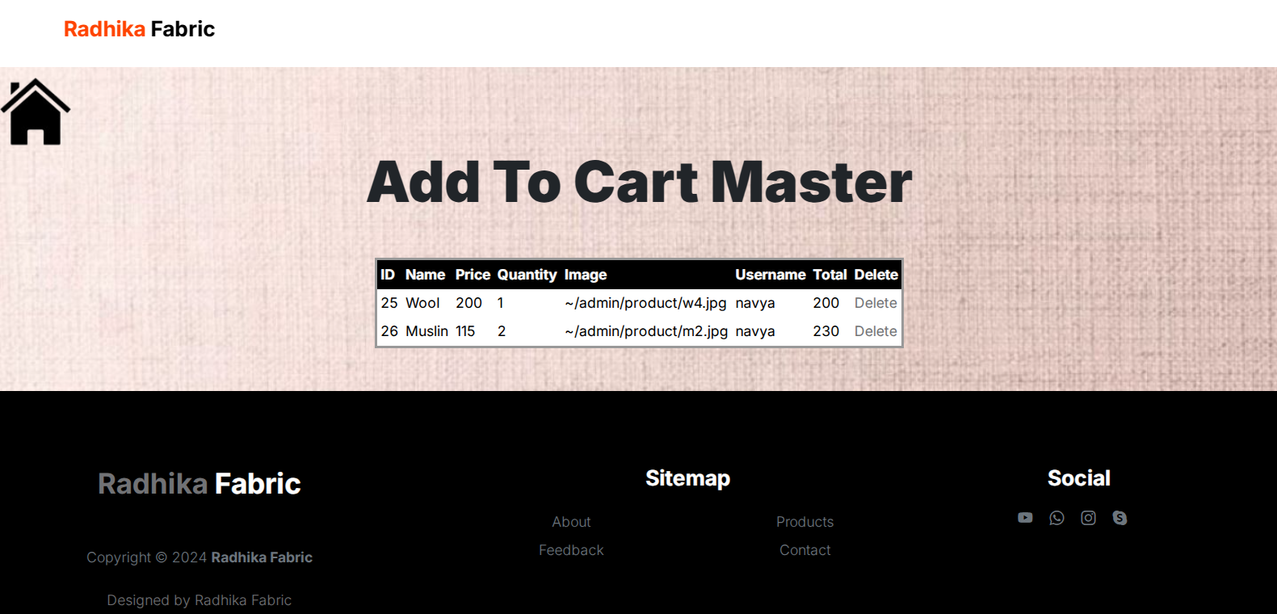

**AddtocartMaster.cs**

using System;

using System.Collections.Generic;

using System.Linq;

using System.Web;

using System.Web.UI;

using System.Web.UI.WebControls;

using System.Data;

using System.Data.SqlClient;

using System.Web.Configuration;

public partial class Admin_addtocart : System.Web.UI.Page

{

SqlConnection con = new SqlConnection();

SqlDataAdapter da = new SqlDataAdapter();

static DataSet ds = new DataSet();

public void refdata()

{

ds.Clear();

da = new SqlDataAdapter("select * from addtocart", con);

da.Fill(ds);

}

public void binddata()

{

GridView1.DataBind();

}

protected void Page_Load(object sender, EventArgs e)

{

con.ConnectionString = WebConfigurationManager.ConnectionStrings["ConnectionString"].ConnectionString;

con.Open();

if (Session["uname"] == null)

{

Response.Redirect("login.aspx");

}

if (!IsPostBack)

{

refdata();

binddata();

}

}

}

**Addtocartdelete.cs**

using System;

using System.Collections.Generic;

using System.Linq;

using System.Web;

using System.Web.UI;

using System.Web.UI.WebControls;

using System.Data;

using System.Data.SqlClient;

using System.Web.Configuration;

public partial class Admin_addtocartdelete : System.Web.UI.Page

{

SqlConnection con = new SqlConnection();

SqlCommand cmd;

int res = 0;

protected void Page_Load(object sender, EventArgs e)

{

con.ConnectionString = WebConfigurationManager.ConnectionStrings["ConnectionString"].ConnectionString;

con.Open();

if (Session["uname"] == null)

{

Response.Redirect("login.aspx");

}

string id = Request.QueryString["id"];

if (id == null)

{

Response.Redirect("addtocartmaster.aspx");

}

cmd = new SqlCommand("delete from addtocart where id=" + id, con);

res = cmd.ExecuteNonQuery();

if (res == 0)

{

Response.Write("<script>alert('Not deleted'); window.location.href='addtocartr.aspx';</script>");

}

else

{

Response.Redirect("addtocart.aspx");

}

con.Close();

}

}

**Client**

**Login.aspx**

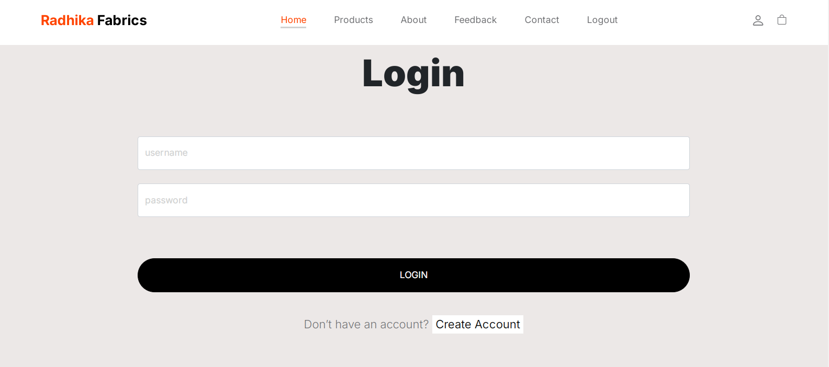

**Login.cs**

using System;

using System.Collections.Generic;

using System.Linq;

using System.Web;

using System.Web.UI;

using System.Web.UI.WebControls;

using System.Web.Configuration;

using System.Data;

using System.Data.SqlClient;

public partial class Client_login : System.Web.UI.Page

{

SqlConnection con = new SqlConnection();

SqlCommand cmd;

protected void Page_Load(object sender, EventArgs e)

{

con.ConnectionString = WebConfigurationManager.ConnectionStrings["ConnectionString"].ConnectionString;

con.Open();

}

protected void btnsubmit_Click(object sender, EventArgs e)

{

DataTable dt = new DataTable();

SqlDataAdapter da = new SqlDataAdapter("select * from registration where username='" + txtuname.Text + "'and password='" + txtpass.Text + "'", con);

da.Fill(dt);

if (dt.Rows.Count == 0)

{

Response.Write("<script>alert('your username or password is wrong'); window.location.href='login.aspx';</script>");

}

else

{

Session["uname"] = txtuname.Text;

Response.Redirect("home.aspx");

}

}

protected void btnsignin_Click(object sender, EventArgs e)

{

Response.Redirect("registration.aspx");

}

}

**Home.aspx**

 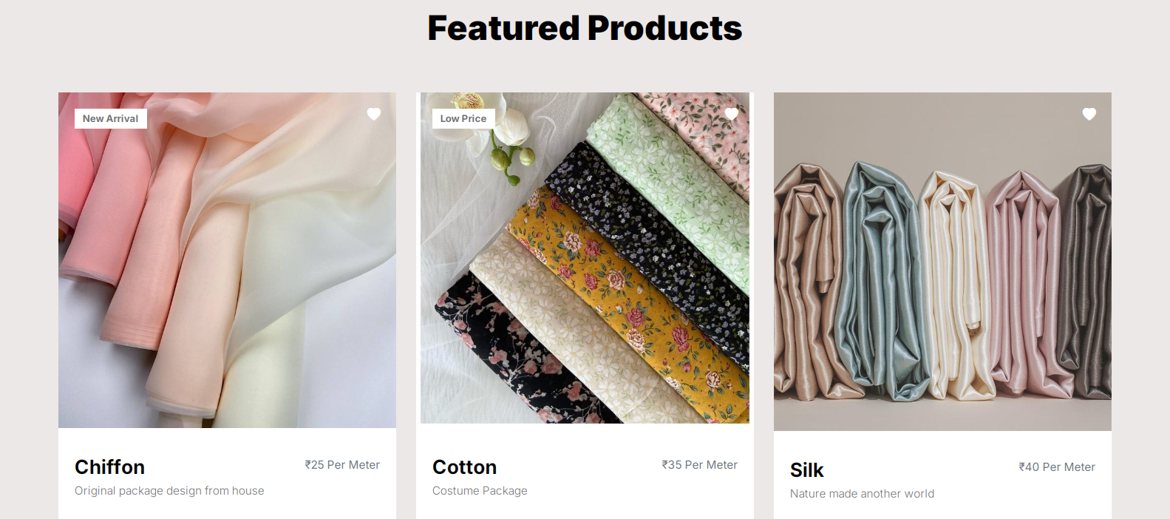

**Product.aspx**

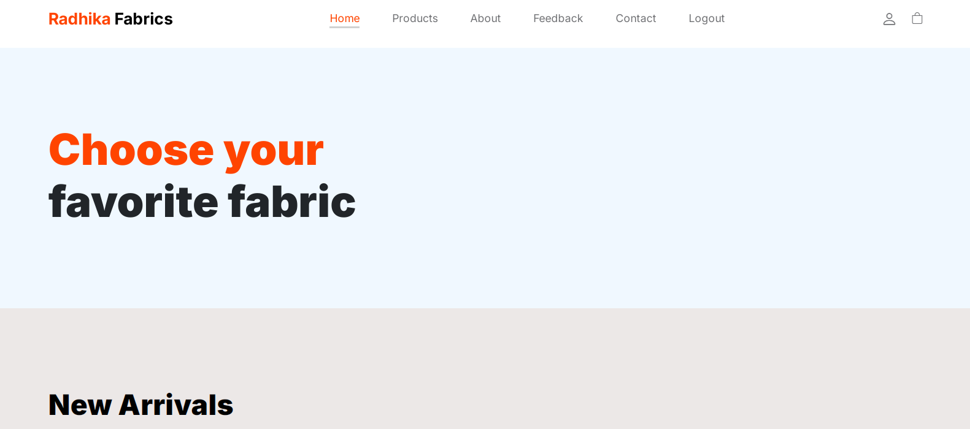



**ViewProduct.cs**

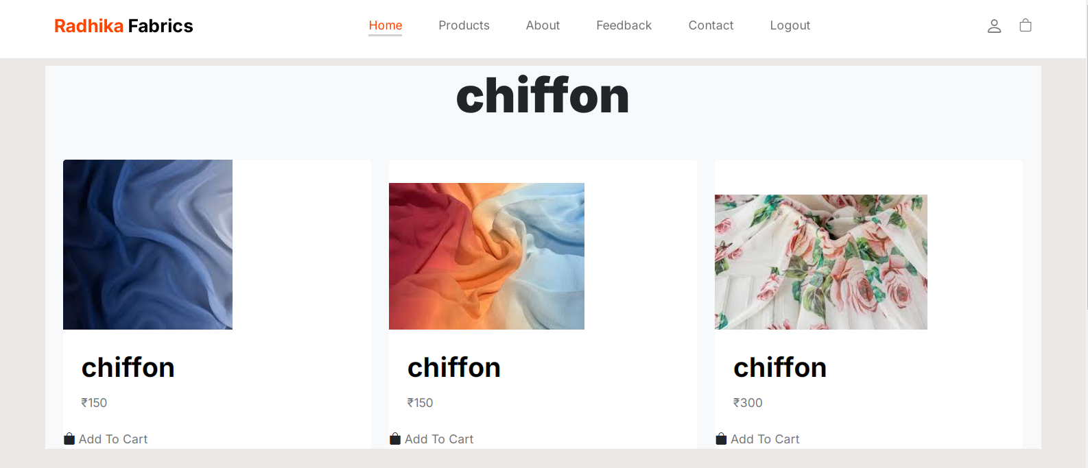

**Viewproduct.cs**

using System;

using System.Collections.Generic;

using System.Linq;

using System.Web;

using System.Web.UI;

using System.Web.UI.WebControls;

using System.Data;

using System.Data.SqlClient;

using System.Web.Configuration;

public partial class Client_viewproduct : System.Web.UI.Page

{

SqlConnection con = new SqlConnection();

SqlCommand cmd;

protected void Page_Load(object sender, EventArgs e)

{

con.ConnectionString = WebConfigurationManager.ConnectionStrings["connectionstring"].ConnectionString;

con.Open();

get_data();

string item = Request.QueryString["item"];

Label1.Text = item;

}

private void get_data()

{

string item = Request.QueryString["item"];

SqlDataAdapter da = new SqlDataAdapter("select * from product where name='" + item + "'", con);

DataTable dt = new DataTable();

da.Fill(dt);

Repeater1.DataSource = dt;

Repeater1.DataBind();

dt.Clear();

}

}

**Addtocart.aspx**

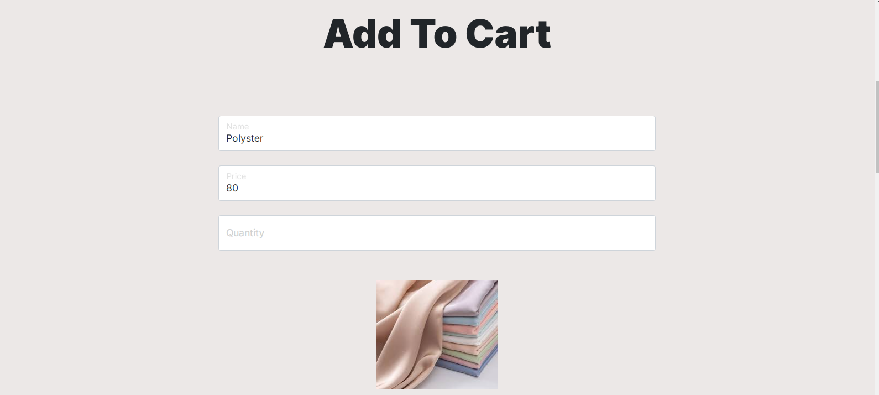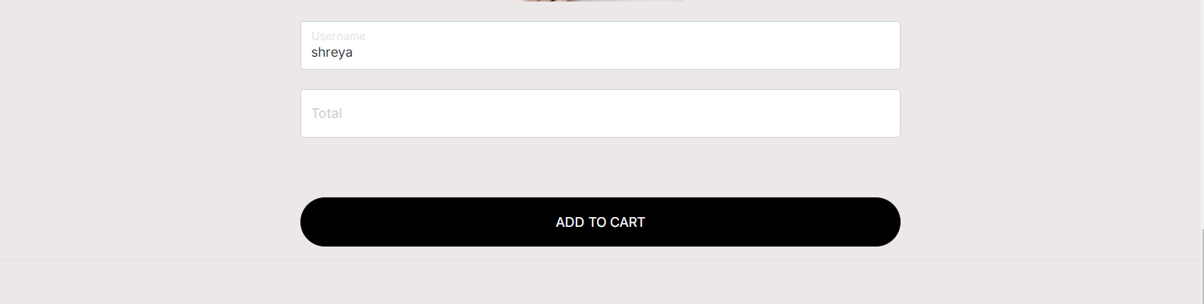

**Addtocart.cs**

using System;

using System.Collections.Generic;

using System.Linq;

using System.Web;

using System.Web.UI;

using System.Web.UI.WebControls;

using System.Data;

using System.Data.SqlClient;

using System.Web.Configuration;

public partial class Client_addtocart : System.Web.UI.Page

{

SqlConnection con = new SqlConnection();

SqlCommand cmd;

protected void Page_Load(object sender, EventArgs e)

{

con.ConnectionString = WebConfigurationManager.ConnectionStrings["connectionstring"].ConnectionString;

con.Open();

if (Session["uname"] == null)

{

Response.Redirect("login.aspx");

}

if (!IsPostBack)

{

int id = Convert.ToInt32(Request.QueryString["id"]);

SqlDataAdapter da = new SqlDataAdapter("select * from product where id=" + id, con);

DataTable dt = new DataTable();

da.Fill(dt);

txtname.Text = dt.Rows[0][1].ToString();

txtprice.Text = dt.Rows[0][3].ToString();

txtusername.Text = Session["uname"].ToString();

img.ImageUrl = "~/admin/product/" + dt.Rows[0][4].ToString();

}

}

protected void btnaddtocart_Click(object sender, EventArgs e)

{

cmd = new SqlCommand("insert into addtocart values(@name,@price,@quantity,@image,@username,@total)", con);

cmd.Parameters.AddWithValue("@name", txtname.Text);

cmd.Parameters.AddWithValue("@price", txtprice.Text);

cmd.Parameters.AddWithValue("@quantity", txtquantity.Text);

cmd.Parameters.AddWithValue("@image", img.ImageUrl);

cmd.Parameters.AddWithValue("@username", Session["uname"].ToString());

cmd.Parameters.AddWithValue("@total", txttotal.Text);

cmd.ExecuteNonQuery();

con.Close();

Response.Redirect("viewcart.aspx");

}

protected void txtquantity_TextChanged(object sender, EventArgs e)

{

int a = Convert.ToInt32(txtprice.Text);

int b = Convert.ToInt32(txtquantity.Text);

int ans = a * b;

txttotal.Text = ans.ToString();

}

}

**Viewcart.aspx**

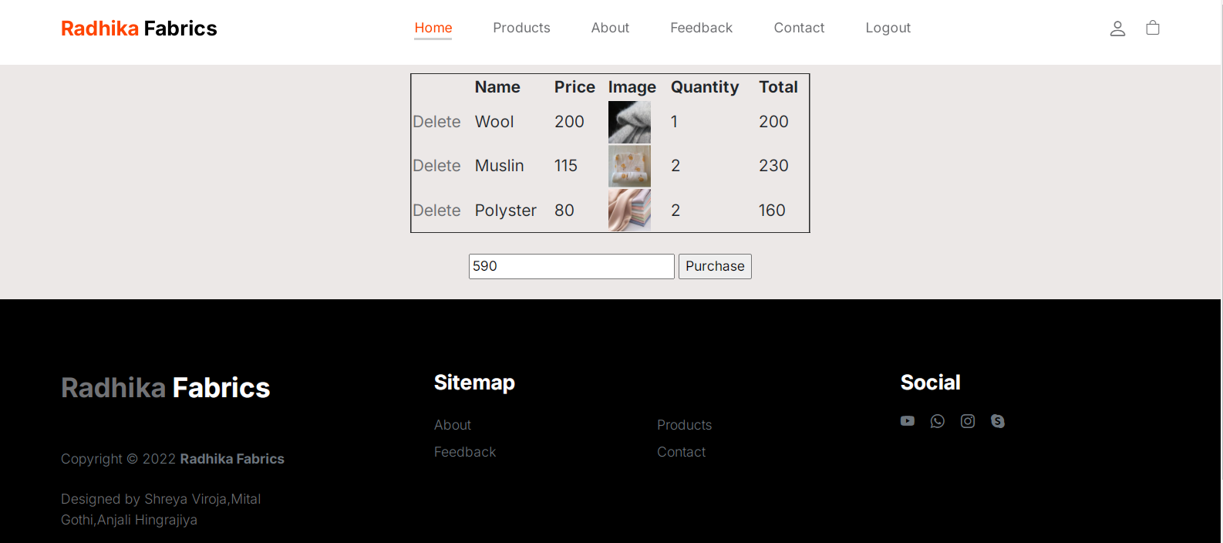

**Viewcart.cs**

using System;

using System.Collections.Generic;

using System.Linq;

using System.Web;

using System.Web.UI;

using System.Web.UI.WebControls;

using System.Data;

using System.Data.SqlClient;

using System.Web.Configuration;

public partial class Client_viewcart : System.Web.UI.Page

{

SqlConnection con = new SqlConnection();

SqlCommand cmd;

int total;

protected void Page_Load(object sender, EventArgs e)

{

con.ConnectionString = WebConfigurationManager.ConnectionStrings["connectionstring"].ConnectionString;

con.Open();

if (Session["uname"] == null)

{

Response.Redirect("login.aspx");

}

get_data();

}

public void get_data()

{

string s = Session["uname"].ToString();

string s1 = "'" + s + "'";

DataTable dt = new DataTable();

SqlDataAdapter da = new SqlDataAdapter("select * from addtocart where username=" + s1, con);

da.Fill(dt);

if (dt.Rows.Count == 0)

{

Response.Write("<script>alert('Cart is empty'); window.location.href='home.aspx';</script>");

}

GridView1.DataBind();

int x = GridView1.Rows.Count;

for (int i = 0; i < x; i++)

{

string username = Session["uname"].ToString();

Label lbltotal = (Label)GridView1.Rows[i].FindControl("lbltotal");

int tot = Convert.ToInt32(lbltotal.Text);

total = total + tot;

txttotal.Text = total.ToString();

}

}

protected void btnpurchase_Click(object sender, EventArgs e)

{

int x = GridView1.Rows.Count;

for (int i = 0; i < x; i++)

{

string username = Session["uname"].ToString();

Label lblname = (Label)GridView1.Rows[i].FindControl("lblname");

string name = lblname.Text.ToString();

Label lblprice = (Label)GridView1.Rows[i].FindControl("lblprice");

int price = Convert.ToInt32(lblprice.Text);

Label lblquantity = (Label)GridView1.Rows[i].FindControl("lblquantity");

int quantity = Convert.ToInt32(lblquantity.Text);

Label lbltotal = (Label)GridView1.Rows[i].FindControl("lbltotal");

int total = Convert.ToInt32(lbltotal.Text);

int t = Convert.ToInt32(txttotal.Text);

cmd = new SqlCommand("insert into purchase values('" + name + "','" + price + "','" + quantity + "','" + username + "','" + total + "')", con);

cmd.ExecuteNonQuery();

cmd = new SqlCommand("delete from addtocart where username='" + username + "'", con);

cmd.ExecuteNonQuery();

Response.Write("<script>alert('congratulations! Thank You For Your Order!! Cash On Delivery... '); window.location.href='home.aspx';</script>");

}

}

protected void GridView1_RowDeleting(object sender, GridViewDeleteEventArgs e)

{

Label id = (Label)GridView1.Rows[e.RowIndex].FindControl("lblid");

int id1 = Convert.ToInt32(id.Text);

cmd = new SqlCommand("delete from addtocart where id=" + id1, con);

cmd.ExecuteNonQuery();

Response.Redirect("viewcart.aspx");

}

}

**About.aspx**



**Feedback.aspx**

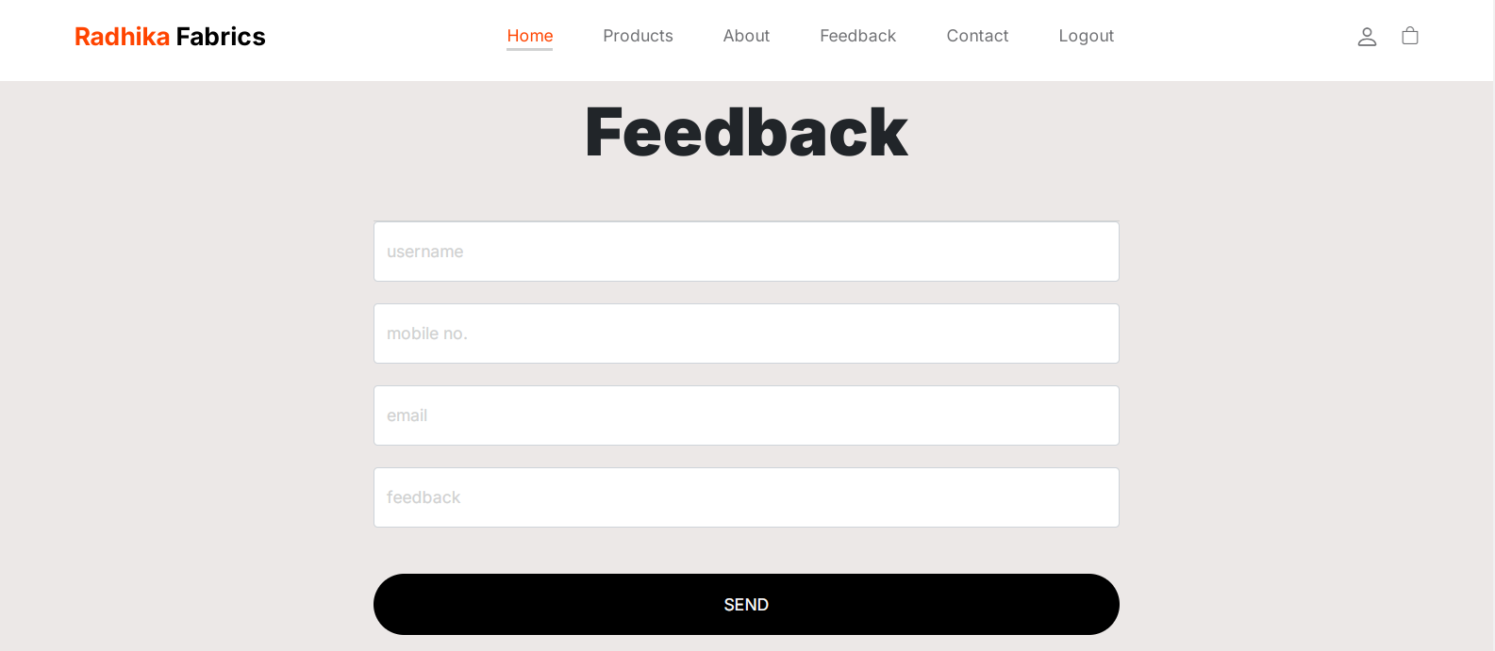

**Feddback.cs**

using System;

using System.Collections.Generic;

using System.Linq;

using System.Web;

using System.Web.UI;

using System.Web.UI.WebControls;

using System.Data;

using System.Data.SqlClient;

using System.Web.Configuration;

public partial class Client_feedback : System.Web.UI.Page

{

SqlConnection con = new SqlConnection();

int res = 0;

protected void Page_Load(object sender, EventArgs e)

{

con.ConnectionString = WebConfigurationManager.ConnectionStrings["ConnectionString"].ConnectionString;

con.Open();

}

protected void btnsubmit_Click(object sender, EventArgs e)

{

SqlCommand cmd = new SqlCommand("insert into feedback values(@name,@mobile,@email,@feedback)", con);

cmd.Parameters.AddWithValue("@name", txtname.Text);

cmd.Parameters.AddWithValue("@mobile", txtmob.Text);

cmd.Parameters.AddWithValue("@email", txtemail.Text);

cmd.Parameters.AddWithValue("@feedback", txtfeed.Text);

res = cmd.ExecuteNonQuery();

if (res == 0)

{

Response.Write("<script>alert('Not inserted'); window.location.href='feedback.aspx';</script>");

}

else

{

Response.Write("<script>alert('Feedback done'); window.location.href='home.aspx';</script>");

//Response.Redirect("home.aspx");

}

con.Close();

}

}

**Contact.aspx**

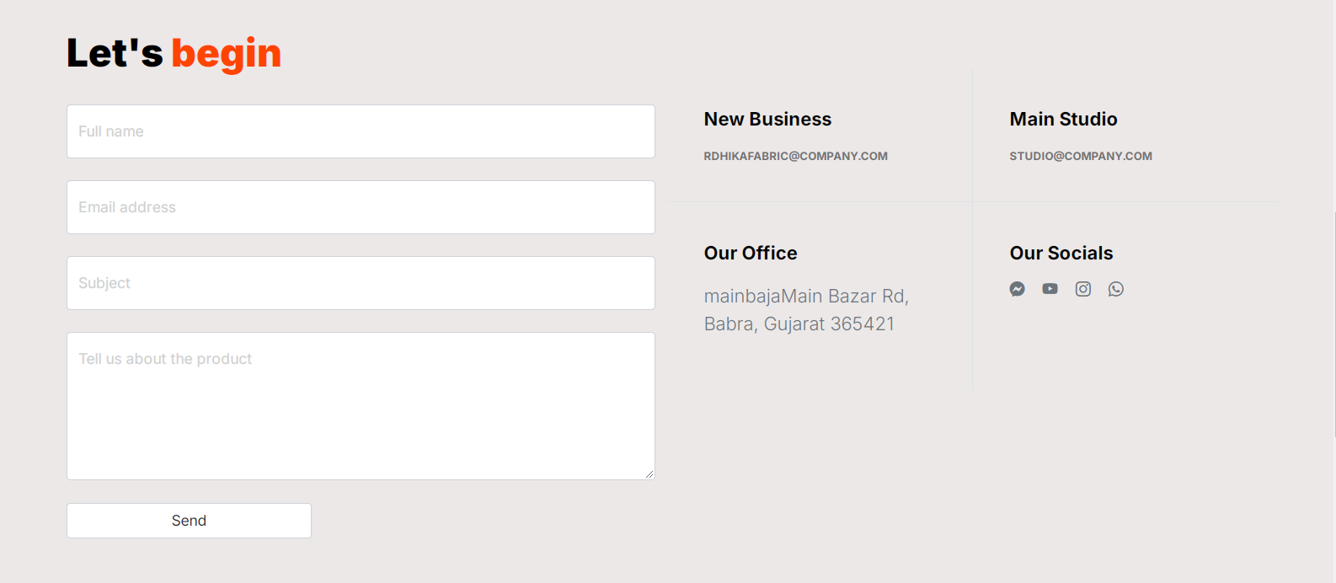

**Logout.cs**

using System;

using System.Collections.Generic;

using System.Linq;

using System.Web;

using System.Web.UI;

using System.Web.UI.WebControls;

public partial class Client_logout : System.Web.UI.Page

{

protected void Page_Load(object sender, EventArgs e)

{

Session.Abandon();

Response.Redirect("login.aspx");

}

}